Course Title |  | Industrial Economics
Year of Study |  | II
Course Code |  | ECO2202
Credit Hours |  | 3
Contact Hours |  | 45
Mode of Delivery |  | Lecture and Tutorial
Pre – requisites |  | None
Mode of Assessment |  |  | Weights (%)
Assignments  Tests  Final Examinations  Total |  |  | 20  20  60  100
Course Description |  | Extensive theoretical and empirical research has been conducted in the area of operations and the environment in which business activities occurs. This research has spawned a clear understanding of the structural, behavioral and performance criteria for evaluation of firms’ success. The course in Industrial Economics or Industrial Organization is tailored to acquaint a learner with economics explanations on the environment, operations and their impact businesses.  By focusing the learners on the economic behavioral aspects that range from those observed at the individual and household level to national and international level; this course is intended to provide an appreciation of business and industrial decision making mechanisms.
Course Objectives |  | This course has been designed to achieve the following objectives, to;  - Provide the student with the theoretical foundation to industrial organization  - Conduct a critical analysis on various industrial structures of any economy  - Determine behavioral aspects of business firms as conditioned by the structure  - Evaluate the business firms’ outcomes, performances and effectiveness
Learning Outcomes |  | Learners of this course shall be expected to achieve the above stated objectives during the training and thereby the assessment of this course in Industrial Economic shall be guided by the following course outcomes;  - Competence to illustrate the various theoretical basis to industrial organization  - Ability to evaluate the various natures of market structures in any economy  - Capacity to assess the different business strategies  - Aptitude in evaluation the various consequences from different market structures
Detailed Course Outline
Serial Number | Topics |  |  | Time Allocation
 | Theoretical Foundations  Introduction: Structure – Conduct – Performance Paradigm, Various Theories of the Firm; Profit Maximization, Baumol’s Sale Revenue Maximization, Williamson’s Managerial Utility Function Maximization Models |  |  | 5 Hours
 | Structural Analysis of the Industry  Concentration: Concepts of Market and Industry; Measures and Interpretation of Concentration; Seller Concentration; Horizontal Mergers  Barriers to Entry: Classifications of Barriers to Entry; Structural Barriers to Entry; Entry – Deterring Strategies; Potential Entry and Contestability; Entry and Industrial Evolution  Models of Oligopoly: (1)Non – collusive models: Cournot, and Stackelberg [Output Determination models]; Bertrand [Price Determination models]; Sweezy’s Kinked Demand curve model; Price leadership (2) Collusive Models: Tendency to Collude, Degree and Form of Collusion, Collusive Institutions, Economic Models of Collusion and Cartel Behavior, Factors Conducive for Cartel Formation and stability |  |  | 15 Hours
 | Analysis of Firm Strategies  Pricing Strategies: Cost Plus; Price Discrimination; Peak – Load Pricing; Transfer Pricing  Auction: Auction Formats and Models; Bidders Valuation; The Pure Common Value Model and Winner Curse; Optimal Bidding Strategies  Product Differentiation: Types of product Differentiation; Monopolistic Competition; Lancaster’s product Characteristic Model; Hotelling’s Location Model; Salop’s Model  Advertising: Determinants of Advertising Expenditure; Advertising and Product Characteristics; Advertising and Profit Maximization; Advertising as a Barrier to Entry: Advertising, Information Search and Quality Signalling  Research and Development: Market Structure, Firm Size and Pace of Technological Change; Investment in Research and Development; Diffusion and Patent  Vertical Integration and Restraints: Motivations; Market Power and Cost Saving; Agency and Vertical Integration; Forms of Vertical Integration  Diversification: Types of Diversification; Motives for Diversification; Corporate Coherence, Focus and Deconglomeration |  |  | 15 Hours
 | Policy Interventions and Effects  Competition Policy: Theoretical Framework; Practical implication;  Regulation: Problems of Natural Regulation; Nationalization; Privatization; Deregulation; Franchising and Competitive Trending |  |  | 10 Hours
Total Contact Hours |  |  |  | 45 Hours
Main References
Lipczyniski, J; Wilson, J; Goddard, J; Industrial Organization, Competition Strategy and Policy, 2nd Edition, Routledge, 29th West 35th Street New York, NY 10001
Joll, C; Kenneth, D; and Lynk E, L; Industrial Organization, Competition, Growth and Structural Change,, Cambridge University Press, The Edinburgh Building, Cambridge, UK

OVERVIEW OF INDUSTRIAL ECONOMICS
INDUSTRIAL REVOLUTION
The Industrial Revolution provided the impetus for developing various management theories and principles. Pre classical theorists like Robert Owen, Charles Babbage, Andrew Ure, Charles Dupin, and Henry R. Towne made some initial contributions that eventually led to the identification of management as an important field of inquiry. This led to the emergence of approaches to management: classical, behavioral, quantitative and modern. The classical management approach had three major branches: scientific management, administrative theory and bureaucratic management. Scientific management emphasized the scientific study of work methods to improve worker efficiency. Bureaucratic management dealt with the characteristics of an ideal organization, which operates on a rational basis. Administrative theory explored principles that could be used by managers to coordinate the internal activities of organizations.
Man has learnt many things which make him civilized. This includes development in terms of infrastructure, technology etc. but one thing which has not changed is change, and things keep on changing on a continuous basis. With the adoption and evolution of management a change was registered that was called the industrial revolution. At the time an acute shortage and un availability of everything is it cloths, material resources, electronic items infrastructure in terms of roads and buildings, technology which make the life comfortable.
There was demand for everything starting from a needle to nuclear bomb and bicycle to rock. In late 15th and 16th century demand, increased tremendously due to the geographical discoveries. It was very difficult to meet the increased demand with the labor intensive techniques; so many scientists were trying their level best to make a balance between the demand and supply by new innovations. The main aim was to increase production. The biggest achievement of that time was the steam engine which helped man to use steam as the power to drive machines. The revolution that started then, has not ended yet and many changes are coming continuously in order to meet the current requirements.
The whole community has benefited from the industrial revolution which is still continuing, some of the contributions of the industrial revolution that can be mentioned are as follows;
- Starting of industries.
- Growth in engineering industries.
- Growth in steel industry
- Growth in cement industry
- Growth in plastic industry.
- Growth in chemical industry
- Development in coal industry
- Growth in paper industry
- Development in automobile industry
- Latest developments in IT industry.
INDUSTRIAL REVOLUTION ON MANAGEMENT THOUGHTS.
Management is an essential part of our day to day life. We cannot think of life without management especially when we have cut throat competition in the market. People are benefiting from the knowledge of management from a long time because the history of management is very demand. Management started almost since men started living in groups. In the beginning management took the form of leadership in order to get the work done from other. Today it is said that the management is the art of getting work done from others in order to achieve the goals of the organization. In those days there were masses converted into groups by the strong men of those times on the basis of their intelligence and physical and mental capabilities. This was done in order to achieve the goals of the groups in order to fulfill the basic requirements of the small groups.
Management started in small groups, then began in the family organizations and later expanded to the tribes and finally suits and today it has taken the form of such importance that it has become the necessary part of everybody is life. Management becomes the mind of the organization.
CLASSICAL THEORY.
Classical theory is the oldest theory among all other theories. It is called the oldest school of thought about the organizations and their accepted views about the organization and many of the views (concepts and principles) hold good even in today’s scenario. It is because the main concentration of classical view was on organization structure in order to achieve the organizational goals with the help of principles developed by classical theorists.
Classical theory consists of the three major viewpoints namely
- Scientific management approach
- Management process or administration management
- Bureaucratic organization.
NEO-CLASSICAL THEORY OR HUMAN RELATION APPROACH.
The neo classical theory was an attempt at incorporating the behavioral sciences into management thought in order to solve the problems caused by classical theory practices. The premise of this inclusion was based on the idea that the role of management is to use employees to get things done in organizations. Rather than focus on production, structures, or technology, the neoclassical theory was concerned with the employee. Neoclassical theorists concentrated on answering questions related to the best way to motivate, structure, and support employees within the organization.
The theory is on improvement over classical theorists had tried to remove the deficiencies of the classical approach. They advocate the need and importance of human relations in the organization. This approach focused on the importance of social and psychological elements in determining the employee’s productivity and satisfaction. The main objective of this approach is to improve interpersonal relations and encourage healthy communication in the organization.
In this approach advocates the importance of human relation in the organization it is known as human relation approach.
DEFINITIONS AND CONCEPT
Industrial economics is the branch of economics which deals the economic problem of firms and industrial relations with society.
Stigliz (1962), viewed industrial economics as a development of microeconomics. He therefore argued that industrial economics is no more than microeconomics. He further differentiated microeconomics and industrial economics as follows;
Industrial economics | Microeconomics
Industrial economics does not believe in single profit maximization but many | Microeconomics believe in a single goal of profit maximization subject to limited
Industrial economics is regarded as an elaboration in depth of microeconomics in studying the theory of the firm | Microeconomics studies theory of a firm and industry and how they behave under given situation
Industrial economics is less formal and more inductive in motive | Microeconomics is a formal deductive and abstract discipline
Industrial economics follows an active approach. It searches for many goal of a firm from revealed facts. It is an active discipline | It is passive in approach, it does not go into operation details of production, distribution, and other aspects of firms and industrial
It concentrate on those constraints which limits the firm to achieve its goals and to stop them | Microeconomics emphasizes the existence of constraints affect the achievement of the firm single goals
Industrial economics take care of (government intervention) public policy implication | Microeconomics may do away with public policy implications
Industrial economics emphasizes the use of empirical data (statistical) so the conclusions derived may be tested empirically | Microeconomics does not emphasize the use of empirical data of the conclusions may not be empirically
1. a) Distinguish between microeconomics and industrial economics
b) What is the major similarity between the two?
CONCEPTS IN INDUSTRIAL ECONOMICS
1. Firm
A firm is an organization owned by one or jointly by few of a few of many individuals which is engaged in productive activity of any kind for sake of making profits or some other well defined aims eg Cola –cola Company, Uganda Bartries, is an industry, Pepsi-cola company, a firm Colgate comp and fresh up company are firms.
Most of the private firms in manufacturing trade service will aim at getting profits but there may be other companies owned by government with different aims other than making profits eg National Water and Sewage Corporation, Uganda cargo.
2. Industry
An industry is defined as a group of sellers of close substitute products which are supplied to a common group of buyers. An industry can be also be also be defined as collection of firms producing close substitutes goods for a common group of buyers.
Ordinarily an industry is a group of firms producing similar /homogeneous or identical good / product and selling in a common market eg Mukwano industry, picfare industry.
3. Market
A market is defined as closely interrelated group of sellers and buyers for a common commodity. An industry is not the same as a market because the industry looks at one side ie the sellers of the market where as the market the seller’s side (industry) and the buyer’s side and other geographical location.
4. Market structure
Market structure refers to different constraint parts of a market as a complex body ie the buyers and sellers link together. Market structure also refers to an arrangement or organization of buyers and sellers linked in the markets.
According to Bain, J.S there are four main features of the market structure which determines behavior of the firms and intern affects their performance as well as the performance of the industry as a whole. The four features or characteristics of a market structure are;
i) The degree of sellers concentration this is the number and size of distribution of sellers (firms) producing a particular commodity in the market eg soft drinks, companies selling drinks located.
ii) The degree of buyers’ concentration
iii) Degree of product differentiation
iv) The conduction of entry and exist to the market, this shows the relative ease with which the new firm can join the existing firm (sellers) in the market eg monopoly.
Qn a) Explain what is meant by a market structure?
b) What are the four features of market structures?
5. Market power
Market power this is used to denote the degree of monopoly arising out of various elements of a market structure;
- The degree of market power of firms or group of firms will determine the price the market
- It will also determine the level of output
- The nature of product
- The level of activity or business (structure)
6. Market conduct
Market conduct is defined as the patterns of bevaviour that firm follow in adopting or adjusting to existing market to achieve well defined goals. If two firms (duopoly) exist in a market they may behave differently or jointly when deciding on firm diversification, effective advertisement and sales company eg;
7. Market performance
Market performance is the end result of activities undertaken by the firms in pursuit of their goals. The examples of indicators of market performance of the firms are;
- High profitability
- Increased in capital turn over
- Increase in employment
- Increase in sales
- New products
- Lower price charged
Qn. Giving examples of indicators of market performance, explain, define the market performance
8. Industrial society
9. Industrial labour
10. Market price
11. Market concentration
THEORY OF THE FIRM
A firm is a production unit under unified control which organizes factors of production to produce goods and services. Or, it’s a production unit that uses the factors of production to produce goods and services.
The term firm therefore is used to refer to business organization as well as the sole proprietorship or even as large as public limited company.
An industry on the other hand is a combination of firms which are engaged in the production of the same kind or similar product.

The management decision of the firm may generally be grouped into four categories.
- The amount of funds to be spent on purchase of inputs.
- The amount of fund on each type of input.
- The quantity of each input to be allocated to each type of input.
- The quantity of each final product to be produced by the firm.

In theory, the major objective of the firm is to maximize profits and the firms decision is made in a such way that profits are maximized when/ where MC = MR. this is referred to as the marginalistic principle. The goal of the firm of profit maximization has however been criticized on the following grounds.
- It has been argued that firms cannot attain the goal of profit maximization because they do not have the necessary knowledge, information nor ability to determine the profits.
- The firms do not know with certainty their demand and cost and so they can’t apply the marginalistic principle.

Profit maximization is therefore not the only goal of the firm and even if firms could attain this goal they may not wish to do so because a modern firm has a number of objectives since it is made up of different people making different decisions.

Objectives of the business (firm) - alternatives to profit maximization
Introduction
In much of economic theory, it is assumed that a business aims to maximize profits.
In reality, most businesses which are run for “commercial gain” do have profit maximization as an important objective – since the shareholders have taken a risk investing in the business and require a return (profit) to compensate them for their risk.
- Managerialism: sales maximisation.
- Behaviorism: aiming at satisfying behavor that is given the constraint firms are not interested in maximizing profits but aim at a satisfactory lel of performance with respect to multiple objectives.
- Longrun survival: managers take actions which aim at maximization of probabilty that they would survive over an indifinate future.
- Entry limitation: this is where the firms set up a price at a such level as to make entry not attractive to other firms. This is sometimes referred to as price limiting or limitation.
- Market sharing goal. This is where the firms aim at increasing their market share of output. (market domination).
Location of Firms and Localization of an Industry
Since the principle objective of firms is to maximize profits, firms will try to locate their establishment at the lowest cost location possible.
Location of firms refers to the establishment of a firm in a given area irrespective of whether there are other firms or not.
Localization of an industry is the concentration of firms producing a given kind of product in a given area usually with intentions of enjoying external economies of scale.
Factors influencing location of firms
1) Market. A firm producing perishable products will locate where there is near market. They want to also go where there is easy access of transport systems in order to reach the market easily. On the other hand, firms that produce goods or products that are not perishable and also easy to transport will be able to start not necessarily near market.
2) Raw materials. When goods are bulky and perishable, firms are set up in areas near the source of raw materials. This is due to the need to reduce the transport cost for the firm and enjoy economies of scale. In instances where the raw materials can be transported easily to the producing firm, the firm may be located far from the source of raw materials.
3) Power. Firm’s location is influenced by power. This is because; most of the firms’ activities require power and therefore a big requirement for them to survive.
4) Labor. Firms would like to locate where there is ready and strong labor supply. There should be high labor supply in order for the firm to spend less as her wage expenditure in order to reduce it costs of production.
5) Water. Firms require a lot of water for its operation either for cooling of machines or even for the purposes of production. Therefore the firms must be either near the water supply or have the water body.
6) Transport and communication. Transport and communication is important because it links the firm to the market as well as the source of raw materials. This is important because in case of perishable products it is easy to transport the produce.
7) Industrial inertia. This is the location of an industry in an area where even when the advantages of industry have ceased.
8) Political climate. Political instability affected areas have less or no firms located in these areas because investors fear that their firms will be destroyed by insecurity and instability.
9) Government policy. Government may influence the location of an industry because it may use taxes and barriers against its construction and supply of its products.
10) Land for expansion.
11) Entrepreneur’s choice.

Factors influencing localization: The similar factors that influence the location of firms apply in this case. Remember to differentiate between location of firms and localization of an industry.

Demerits of location of firms
1) Pollution. It is likely to occur due to the waste products from these firms. This affects human and water animal life leading to disease and death.
2) Congestion. Localization of firms tends to result to human and traffic congestion which leads to time wastage.
3) Overstraining infrastructure. As firms concentrate in a given area, the available infrastructure is likely to be over strained and thus unable to serve the people in the area.
4) Rural urban migration. Firms attract labor which is employed. Therefore firms becomes pull agent. This usually denies the useful labor that instead migrates to urban areas.
5) Unemployment. Partly because of rural urban migration and partly because of the high population growth rate. Open urban unemployment tends to result due to the fact that the rate at which jobs are heated is far lower than the rate at which they are demanded.
6) Uneven development. Localization of firms result into uneven development of regions that is, there is higher rates of development in areas that firms concentrate in and lower rates in areas that are void of firms.
7) Increased costs of factors of production. When firm concentrate in a given area, the costs of factors of production tends to rise due to the increased demand for them relative to their supply. This is especially the case for land whose supply is fixed.
8) Growth of slums and their related problems

REFERENCE
MICHAEL. E. PORTER (1985).( Competitive Advantage. )Free Press,
CHARLES (2000) (Understanding the Industrial Revolution) London: Routledge
RONALD G. EHRENBERG, ROBERT S. SMITH (modern labour economics) fourth edition published in 1991
WILLIAM H. HOLLEY, KENNETH M. JENNINGS (The labor relations and process) sixth edition published in1997

According to Petersen and Lewis (2004) is the way how markets are arranged and organized. This implies the criteria for categorizing markets.

A market structure can be defined as those organizational features of a market which have a significant influence on the nature of composition. These features include the following:
- The number of sellers in a market. In some cases consumers will have little choice – we cannot choose which firm we buy our water from.
- The number of buyers. For most consumer goods, there may be millions of buyers, but for some products (e.g. tanks, traffic lights), there may a few potential buyers, which gives the latter a strong position in any negotiations.
- The size of the firms in an industry. A firm may be, say, the only manufacturer of shrouds for coffins, but this monopoly position will not give it much market power, since other textile firms could easily produce shrouds if they thought it was profitable.
- Product differentiation. This occurs when a manufacturer makes many varieties of the basic product. This can be demonstrated at any supermarket, where one manufacturer will be seen to supply many varieties of crisps, while another may provide several different shampoos.
- Ease of entry and exist. Is it easy to enter the business? Anyone can start up as a hairdresser, so entry is easy, particularly as the equipment needed is relatively cheap. At the extreme, to manufacture airplanes or set up a nuclear power station is very difficult, and so the barriers to entry are huge.

Market structure is important because it affects the firm’s conduct. At one extreme there may be an industry with only one seller but making many products, with many buyers, and with large barriers to entry. Such a firm can be expected to be able to charge high prices and to make big profits without much need to spend on investment. At the other extreme, a small firm facing lots of competitors and only a few will be in a weak position.

In turn, the firm’s conduct will affect its performance. With little competition, a firm may be relatively inefficient but still be very profitable. A firm in a very competitive industry will often be forced to keep its prices down, thus becoming very efficient, but making only low profits.

The structure, conduct and performance model

E.g. number of buyers e.g. firm’s goals e.g. efficiency
and sellers

Market
Structure
Conduct
Performance.

The Firm under perfect Competition

Market Structure comparison Market Structure comparison
Characteristic | Number of firms | Market power | Elasticity of demand | Product differentiation | Excess profits | Efficiency | Profit maximization condition | Pricing power
Perfect comp Perfect competition | Infinite | None | Perfectly elastic | None | No | Yes | P = MC = MR | Price taker
Monopolistic competition | Many | Low | Highly elastic (long run) | High | Yes/No (Short/Long) | No | MR=MC | Price setter
Monopoly o | One | High | Relatively inelastic | Absolute (across industries) | Yes | No | MR=MC | Price setter
Oligopoly | Few | High | Elastic and inelastic | Differentiated or identical | Yes/No  (short/long) | No | MC = MR | Price setter

Imperfect competition
In economic theory, imperfect competition is the competitive situation in any market where the conditions necessary for perfect competition are not satisfied. It is a market structure that does not meet the conditions of perfect competition.
Forms of imperfect competition include:
- http://en.wikipedia.org/wiki/MonopolyMonopoly, in which there is only one seller of a good.
- Oligopoly, in which there is a small number of sellers.
- Monopolistic competition, in which there are many sellers producing highly, differentiated goods.
- Monopsony, in which there is only one buyer of a particular good a factor of production.
- Oligopsony, in which there is a small number of buyers.
- Causes of Oligopoly:
- The main reasons which give rise to oligopoly are as follows:
- (i) Economies of scale: If the productive capacity of a few firms is large and are able to capture a greater percentage of the total available demand for the product in the market, there will then be a small number of firms in an Industry. The firms in the industry with heavy investment, using improved technology and reaping economies of scale in production, sales, promotion, etc., will compete and stay in the market. The firms using outdated machinery and old techniques of production will not be able to compete with the low unit costs producing firms and eventually wipe out from the industry. Oligopoly is, thus, promoted due to the economies of scale.
- (ii) Barriers to entry: In many oligopolies, the new firms cannot enter the industry as the big firms have ownership of patents or control over the essential raw material used in the production of an output. The heavy expenditure on advertising by the oligopolistic industries may also be a financial barrier for the new firms to enter the industry.
- (iii) Merger: If the few firms in the industry smell the danger of entry of new firms, they then immediately merge and formulate a joint policy in the pricing and production of the products.

- The joint actions of a few big firms discourage the entry of new firms into the industry.

- (iv) Mutual interdependence: As the number of firms is small in an

- Oligopolistic industry, therefore, they keep a strict watch of the price charged by rival firms in the industry. The firm generally avoids price war and tries to create conditions of mutual interdependence
Price discrimination or price differentiation,exists when sales of identical goods or services are transacted at different prices from the same provider.^{[2]} In a theoretical market with perfect information, perfect substitutes, and no transaction costs or prohibition on secondary exchange (or re-selling) to prevent arbitrage, price discrimination can only be a feature of monopolistic and oligopolistic markets, where market power can be exercised.
Types of price discrimination

First degree price discrimination
This type of price discrimination requires the monopoly seller of a good or service to know the absolute maximum price (or reservation price) that every consumer is willing to pay. By knowing the reservation price, the seller is able to absorb the entire consumer's surplus from the consumer and transform it into revenues. The seller produces more of his product than he would to achieve monopoly profits with no price discrimination, which means that there is no deadweight loss. Examples of where this might be observed are in markets where consumers bid for tenders, though, in this case, the practice of collusive tendering could reduce the market efficiency.
In second degree price discrimination, price varies according to quantity demanded. Larger quantities are available at a lower unit price. This is particularly widespread in sales to industrial customers, where bulk buyers enjoy higher discounts.
In third degree price discrimination, price varies by attributes such as location or by customer segment, or in the most extreme case, by the individual customer's identity; where the attribute in question is used as a proxy for ability/willingness to pay.
In fourth degree price discrimination, prices are the same for different customers, however costs to the organization may vary. For example, one may buy a plane ticket, but call ahead to order a vegetarian meal, possibly costing the company more to provide, but your ticket has no greater cost to you. This is also known as reverse price discrimination, as the effects are reflected on the producer.

Combination
These types are not mutually exclusive. Thus a company may vary pricing by location, but then offer bulk discounts as well. Airlines use several different types of price discrimination, including:
- Bulk discounts to wholesalers, consolidators, and tour operators
- Incentive discounts for higher sales volumes to travel agents and corporate buyers
- Seasonal discounts, incentive discounts, and even general prices that vary by location. The price of a flight from say, Singapore to Beijing can vary widely if one buys the ticket in Singapore compared to Beijing (or New York or Tokyo or elsewhere).
- Discounted tickets requiring advance purchase and/or Saturday stays. Both restrictions have the effect of excluding business travelers, who typically travel during the workweek and arrange trips on shorter notice.
- First degree price discrimination based on customer. It is not accidental that hotel or car rental firms may quote higher prices to their loyalty program's top tier members than to the general public.

Modern taxonomy
The first/second/third degree taxonomy of price discrimination is due to Pigou (Economics of Welfare, 4th edition, 1932). Ivan Png (Managerial Economics, 2nd edition, 2002) suggests an alternative taxonomy:
- Complete discrimination -- where each user purchases up to the point where the user's marginal benefit equals the marginal cost of the item;
- Direct segmentation -- where the seller can condition price on some attribute (like age or gender) that directly segments the buyers;
- Indirect segmentation -- where the seller relies on some proxy (e.g., package size, usage quantity, coupon) to structure a choice that indirectly segments the buyers.
The hierarchy—complete/direct/indirect—is in decreasing order of
- profitability and
- information requirement.
Complete price discrimination is most profitable, and requires the seller to have the most information about buyers. Indirect segmentation is least profitable, and requires the seller to have the least information about buyers.

Two part tariff
The two-part tariff is another form of price discrimination where the producer charges an initial fee then a secondary fee for the use of the product. An example of this is razors; you pay an initial cost for the razor and then pay for the replacement blades. Explanation

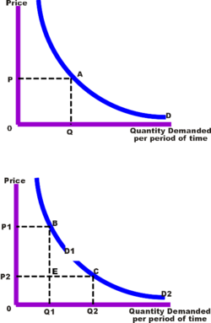
Sales revenue without and with Price Discrimination
In the top diagram, a single price (P) is available to all customers. The amount of revenue is represented by area P, A, Q, O. The consumer surplus is the area above line segment P, A but below the demand curve (D).
With price discrimination, (the bottom diagram), the demand curve is divided into two segments (D1 and D2). A higher price (P1) is charged to the low elasticity segment, and a lower price (P2) is charged to the high elasticity segment. The total revenue from the first segment is equal to the area P1,B, Q1,O. The total revenue from the second segment is equal to the area E, C,Q2,Q1. The sum of these areas will always be greater than the area without discrimination assuming the demand curve resembles a rectangular hyperbola with unitary elasticity.
It is very useful for the price discriminator to determine the optimum prices in each market segment. This is done in the next diagram where each segment is considered as a separate market with its own demand curve. As usual, the profit maximizing output (Qt) is determined by the intersection of the marginal cost curve (MC) with the marginal revenue curve for the total market (MRt).
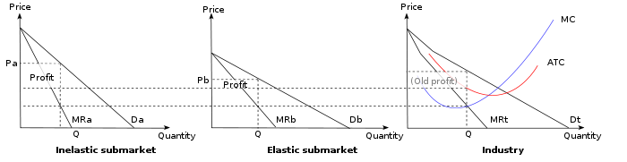
Multiple Market Price Determination
The firm decides what amount of the total output to sell in each market by looking at the intersection of marginal cost with marginal revenue (profit maximization). This output is then divided between the two markets, at the equilibrium marginal revenue level. Therefore, the optimum outputs are Qa and Qb. From the demand curve in each market we can determine the profit maximizing prices of Pa and Pb.

Examples of price discrimination

Retail price discrimination

Travel industry

Coupons

Premium pricing

Segmentation by age group and student status

Discounts for members of certain occupations

Employee discounts

Retail incentives

Incentives for industrial buyers

Sex-based examples

"Ladies' night"

Dry cleaning

Haircutting

Automobile Insurance

Financial aid in education

Haggling

International price discrimination

Academic pricing

Dual pricing

Wage discrimination

Universal pricing
Universal pricing is the opposite of price discrimination — one price is offered for the good or service. This is usually preferred by consumers over tiered pricing. For example, the European Union is currently making efforts to set a single-price protocol for automobile sales.

Two necessary conditions for price discrimination
There are two conditions that must be met if a price discrimination scheme is to work. First the firm must be able to identify market segments by their price elasticity of demand and second the firms must be able to enforce the scheme.
User-controlled price discrimination
While the conventional theory of price discrimination generally assumes that prices are set by the seller, there is a variant form in which prices are set by the buyer, such as in the form of pay what you want pricing.
Introductory questions
There are, of course, many problems that these parties would immediately run into.
- How much time, energy, or money should the sender (agent) spend on sending the signal?
- How can the receiver (the principal, who is usually the buyer in the transaction) trust the signal to be an honest declaration of information?
- Assuming there is a signalling equilibrium under which the sender signals honestly and the receiver trusts that information, under what circumstances will that equilibrium break down?

Collusion is an agreement between two or more parties, sometimes illegal and therefore secretive, to limit open competition by deceiving, misleading, or defrauding others of their legal rights, or to obtain an objective forbidden by law typically by defrauding or gaining an unfair advantage. It is an agreement among firms or individuals to divide a market, set prices, limit production or limit opportunities.
In the study of economics and market competition, collusion takes place within an industry when rival companies cooperate for their mutual benefit. Collusion most often takes place within the market structure of oligopoly, where the decision of a few firms to collude can significantly impact the market as a whole. Cartels are a special case of explicit collusion.
Indicators
Practices that suggest collusion include:
- Uniform prices
- A penalty for price discounts
- Advance notice of price changes
- Information exchange

Examples
- Market division and price-fixing among manufacturers of heavy electrical equipment in the 1960s, including General Electric.^{[4]}
- An attempt by Major League Baseball owners to restrict players' salaries in the mid-1980s.
- The sharing of potential contract terms by NBA free agents in an effort to help a targeted franchise circumvent the salary cap
- Price fixing within food manufacturers providing cafeteria food to schools and the military in 1993.
- Market division and output determination of livestock feed additive, called lysine, by companies in the US, Japan and South Korea in 1996, Archer Daniels Midland being the most notable of these.^{[5]}
- Chip dumping in poker or any other high stake card game.
There are many ways that implicit collusion tends to develop:
- The practice of stock analyst conference calls and meetings of industry participants almost necessarily results in tremendous amounts of strategic and price transparency. This allows each firm to see how and why every other firm is pricing their products.
- If the practice of the industry causes more complicated pricing, which is hard for the consumer to understand (such as risk-based pricing, hidden taxes and fees in the wireless industry, negotiable pricing), this can cause competition based on price to be meaningless (because it would be too complicated to explain to the customer in a short advertisement). This causes industries to have essentially the same prices and compete on advertising and image, something theoretically as damaging to consumers as normal price fixing.

Barriers
There can be significant barriers to collusion. In any given industry, these may include:
- The number of firms: As the number of firms in an industry increases, it is more difficult to successfully organize, collude and communicate.
- Cost and demand differences between firms: If costs vary significantly between firms, it may be impossible to establish a price at which to fix output.
- Cheating: There is considerable incentive to cheat on collusion agreements; although lowering prices might trigger price wars, in the short term the defecting firm may gain considerably. This phenomenon is frequently referred to as "chiseling".
- Potential entry: New firms may enter the industry, establishing a new baseline price and eliminating collusion (though anti-dumping laws and tariffs can prevent foreign companies entering the market).
- Economic recession: An increase in average total cost or a decrease in revenue provides incentive to compete with rival firms in order to secure a larger market share and increased demand.
A cartel
An organization of independent firms with in the same line of production that come together with an aim of reducing competition so as to acquire monopoly powers in the long run to increase the profits of its members.

Functions of a cartel
- Determines market price for the output of the industry.
- Determines the output quota of a firm in the industry.
- Determines output to be produced by entire industry.
- Markets the output of the industry.
- Determines the profits among the firms in the industry,

- Imperfect collusion in form of price leadership. Price leadership refers to a price in the oligopoly industry where one firm decides the price for other firms to follow.
Price can be set by a dominant firm or a low cost firm.

Forms of price leadership
- Barometric price leadership. There is no leadership firm one which is skillful announces the price change by estimating demand and cost conditions and other firms follow on the basis of tacit agreement.
- Dominant price leadership. The biggest firm in the industry dominates the market like a monopolist and sets the profit maximization price for its goods so other will just follow due to the fear of eliminating them from the market. It is also called partial monopolist price leadership.
- Aggressive or exploitative price leadership. Dominant firm fixes maximum price for itself so it might set a low price which scares away other firms in the industry so as to stay alone in the industry in the long run.
- Affective price leadership. This is mainly found in industries with few firms with identical cost condition having elastic demand for their products. These few firms set the price that the rest of the firms follow. Such price leadership is active in suppressing competition among the oligopoly firms.

Diversification.
It’s the act or practice of manufacturing a variety of products, investing in a variety of securities, selling a variety of merchandise etc so that any failure in or an economic slump affecting one of them will not be disastrous e.g. Firms producing shoes start producing other leather products like belts, motor vehicle seats, leather bags and jackets etc. So it’s thus the spreading of operation by business over different economic activities.
Industrial diversification is a strategy that involves choosing to structure a company operation in a manner that promotes involvement in a wide range of revenue producing activities. An approach of this type may have to do with the production of goods and services associated with the business, or may focus more on how the company chooses to arrange its investment portfolio.
An industry is said to be diversified when it has multiple, unrelated businesses. Unrelated businesses are those which;
    - Require unique management expertise.
    - Have different end customers.
    - Produce different products or provide different services.
One of the benefits of being a diversified is that it buffers a company from dramatic fluctuations in any one industry sector.
On the other hand diversification has the highest level of risk and requires the most careful investigation. Going into an unknown market with an unfamiliar product with lack of experience in the new skills and techniques required. Therefore, the company puts itself in a great uncertainty. Moreover, diversification might necessitate significant expanding of human and financial resources, which may detract focus, commitment, and sustained investments. Therefore, a firm should choose this option only when the current product or current market orientation does not offer further opportunities for growth in order to measure the chances of success.

Advantages:
- The unrelated diversification which is carefully developed and undertaken only after thorough analysis of the environment and the company´s own resources usually brings very good financial results. However, in all cases it should be a low risk investment with a potential for high returns.
- In some cases of company acquisition, this diversification can secure funds on hand during a seasonal slowdown, adding to the cash flow for the main business activity.
- Spreading the risk through different sectors of the economy. It is very important to identify industries in which the business activity slowdown does not coincide with the slowdowns in the main business of the company.
- High profit opportunities. Ability to move into high growth profitable industries especially important if current industry is in decline and also helps industries escape from the present business if competition is too hot!
Disadvantages:
- Achieving successful unrelated diversification requires good management skills, closely following each of the business activities and timely identifying and solving even the smallest problems. The greater the number of business activities, the more difficult is the total management task.

- In many instances the overall performance of the unrelated business activities does not exceed the individual ones. Sometimes it is even worse, unless the managers are exceptionally talented and focused.

- As a rule, the implementation of unrelated diversification strategy requires allocation of significant financial and human resources and there is always the risk of harming the main company business.
Depending on the direction of company diversification, the different types are:
- Horizontal Diversification. Acquiring or developing new products or offering new services that could appeal to the company´s current customer groups. In this case the company relies on sales and technological relations to the existing product lines. For example a dairy, producing cheese adds a new type of cheese to its products.

- Vertical Diversification. Occurs when the company goes back to previous stages of its production cycle or moves forward to subsequent stages of the same cycle - production of raw materials or distribution of the final product. For example, if you have a company that does reconstruction of houses and offices and you start selling paints and other construction materials for use in this business. This kind of diversification may also guarantee a regular supply of materials with better quality and lower prices.

- Concentric Diversification. Enlarging the production portfolio by adding new products with the aim of fully utilizing the potential of the existing technologies and marketing system. The concentric diversification can be a lot more financially efficient as a strategy, since the business may benefit from this diversification model. It may enforce some investments related to modernizing or upgrading the existing processes or systems. This type of diversification is often used by small producers of consumer goods, e.g. a bakery starts producing pastries or dough products.

- Conglomerate Diversification. Is moving to new products or services that have no technological or commercial relation with current products, equipment, distribution channels, but which may appeal to new groups of customers. The major motive behind this kind of diversification is the high return on investments in the new industry. Furthermore, the decision to go for this kind of diversification can lead to additional opportunities indirectly related to further developing the main company business - access to new technologies, opportunities for strategic partnerships, etc.

- Corporate Diversification. Involves production of unrelated but definitely profitable goods. It is often tied to large investments where there may also be high returns.

Mergers and Acquisitions:

One plus one makes three: this equation is the special alchemy of a merger or an acquisition. The key principle behind buying a company is to create shareholder value over and above that of the sum of the two companies. Two companies together are more valuable than two separate companies - at least, that's the reasoning behind M&A. This rationale is particularly alluring to companies when times are tough. Strong companies will act to buy other companies to create a more competitive, cost-efficient company. The companies will come together hoping to gain a greater market share or to achieve greater efficiency. Because of these potential benefits, target companies will often agree to be purchased when they know they cannot survive alone.

Distinction between Mergers and Acquisitions

Although they are often uttered in the same breath and used as though they were synonymous, the terms merger and acquisition mean slightly different things.
When one company takes over another and clearly established itself as the new owner, the purchase is called an acquisition. From a legal point of view, the target company ceases to exist, the buyer "swallows" the business and the buyer's stock continues to be traded.
In the pure sense of the term, a merger happens when two firms, often of about the same size, agree to go forward as a single new company rather than remain separately owned and operated. This kind of action is more precisely referred to as a "merger of equals." Both companies' stocks are surrendered and new company stock is issued in its place. For example, both Daimler-Benz and Chrysler ceased to exist when the two firms merged, and a new company, DaimlerChrysler, was created.
In practice, however, actual mergers of equals don't happen very often. Usually, one company will buy another and, as part of the deal's terms, simply allow the acquired firm to proclaim that the action is a merger of equals, even if it's technically an acquisition. Being bought out often carries negative connotations, therefore, by describing the deal as a merger, deal makers and top managers try to make the takeover more palatable.
A purchase deal will also be called a merger when both CEOs agree that joining together is in the best interest of both of their companies. But when the deal is unfriendly - that is, when the target company does not want to be purchased - it is always regarded as an acquisition.
Whether a purchase is considered a merger or an acquisition really depends on whether the purchase is friendly or hostile and how it is announced. In other words, the real difference lies in how the purchase is communicated to and received by the target company's board of directors, employees and shareholders.
Synergy
Synergy is the magic force that allows for enhanced cost efficiencies of the new business. Synergy takes the form of revenue enhancement and cost savings. By merging, the companies hope to benefit from the following:
- Staff reductions - As every employee knows, mergers tend to mean job losses. Consider all the money saved from reducing the number of staff members from accounting, marketing and other departments. Job cuts will also include the former CEO, who typically leaves with a compensation package.
- Economies of scale - Yes, size matters. Whether it's purchasing stationery or a new corporate IT system, a bigger company placing the orders can save more on costs. Mergers also translate into improved purchasing power to buy equipment or office supplies - when placing larger orders, companies have a greater ability to negotiate prices with their suppliers.
- Acquiring new technology - To stay competitive, companies need to stay on top of technological developments and their business applications. By buying a smaller company with unique technologies, a large company can maintain or develop a competitive edge.
- Improved market reach and industry visibility - Companies buy companies to reach new markets and grow revenues and earnings. A merge may expand two companies' marketing and distribution, giving them new sales opportunities. A merger can also improve a company's standing in the investment community: bigger firms often have an easier time raising capital than smaller ones.
That said, achieving synergy is easier said than done - it is not automatically realized once two companies merge. Sure, there ought to be economies of scale when two businesses are combined, but sometimes a merger does just the opposite. In many cases, one and one add up to less than two.
Sadly, synergy opportunities may exist only in the minds of the corporate leaders and the deal makers. Where there is no value to be created, the CEO and investment bankers - who have much to gain from a successful M&A deal - will try to create an image of enhanced value. The market, however, eventually sees through this and penalizes the company by assigning it a discounted share price. We'll talk more about why M&A may fail in a later section of this tutorial.
Varieties of Mergers
From the perspective of business structures, there is a whole host of different mergers. Here are a few types, distinguished by the relationship between the two companies that are merging:
- Horizontal merger - Two companies that are in direct competition and share the same product lines and markets.
- Vertical merger - A customer and company or a supplier and company. Think of a cone supplier merging with an ice cream maker.
- Market-extension merger - Two companies that sell the same products in different markets.
- Product-extension merger - Two companies selling different but related products in the same market.
- Conglomeration - Two companies that have no common business areas.
There are two types of mergers that are distinguished by how the merger is financed. Each has certain implications for the companies involved and for investors:
  - Purchase Mergers - As the name suggests, this kind of merger occurs when one company purchases another. The purchase is made with cash or through the issue of some kind of debt instrument; the sale is taxable.
Acquiring companies often prefer this type of merger because it can provide them with a tax benefit. Acquired assets can be written-up to the actual purchase price, and the difference between the book value and the purchase price of the assets can depreciate annually, reducing taxes payable by the acquiring company. We will discuss this further in part four of this tutorial.
  - Consolidation Mergers - With this merger, a brand new company is formed and both companies are bought and combined under the new entity. The tax terms are the same as those of a purchase merger.
Acquisitions
As you can see, an acquisition may be only slightly different from a merger. In fact, it may be different in name only. Like mergers, acquisitions are actions through which companies seek economies of scale, efficiencies and enhanced market visibility. Unlike all mergers, all acquisitions involve one firm purchasing another - there is no exchange of stock or consolidation as a new company. Acquisitions are often congenial, and all parties feel satisfied with the deal. Other times, acquisitions are more hostile.
In an acquisition, as in some of the merger deals we discuss above, a company can buy another company with cash, stock or a combination of the two. Another possibility, which is common in smaller deals, is for one company to acquire all the assets of another company. Company X buys all of Company Y's assets for cash, which means that Company Y will have only cash (and debt, if they had debt before). Of course, Company Y becomes merely a shell and will eventually liquidate or enter another area of business.
Another type of acquisition is a reverse merger, a deal that enables a private company to get publicly-listed in a relatively short time period. A reverse merger occurs when a private company that has strong prospects and is eager to raise financing buys a publicly-listed shell company, usually one with no business and limited assets. The private company reverse merges into the public company, and together they become an entirely new public corporation with tradable shares.
Regardless of their category or structure, all mergers and acquisitions have one common goal: they are all meant to create synergy that makes the value of the combined companies greater than the sum of the two parts. The success of a merger or acquisition depends on whether this synergy is achieved.

Advertising strategy
A campaign developed by a business to encourage potential customers to purchase a good or service.an advertising strategy is generally tailored to a target audience perceived to be mostly likely out of the population to purchase the product. Advertising strategies include elements such as geographical location, perceived demographics of the audience, price points, special offers, and what advertising media, such as billboards, website, or television, will be used to present the product
Or
it can also be defined as a blueprint to help sell a given product to consumers.
Roles of advertising
- Advertising is an unnecessary business costs which has the effect of raising price
- It is used to increase business concentration and ,thus ,opens industries to the abuse of monopoly
- To much expenditure on advertising creates spurious product differentiation and induce consumers to objective information
- Heavy dependence on modern press for it’s survival on advertisement is seen as a positive one
- It helps in increasing the demand for a product and thus opens the way for large scale production it lower cost which ultimately passed on to the consumers in terms of lower price they pay for the product
- Advertisement adds psychological value to products leading to increased consumer satisfaction
- Advertisement increases the variety and quality of goods offered and stimulates competition in technical progress
- Advertising subsidies the press and television services and thus helps in providing employment
- Market role-it plays a big role in marketing the product and service.
Marketing is a business process that’s aim to satisfy the consumers needs and wants through goods and service. Advertising lets the message out to take that big role in marketing to promote goods and services
Communication role. This one role of advertising that transmits the needed information about the goods or services to the target market
Economic role. It places a big role in the price elasticity of products and services

Societal role. Show what the trend in the society is on or that could be nest big thing in the society. It can be both reflecting the society or start to engage what the society can expect in the near future

Major criticisms
- Much of the advertising is false and misleading .the essential purpose of adverting is to pursue the consumer to buy a product by giving them correct information for decision making. But the promises instead turns out to be false and misleading
- Too much proliferation through advertising makes the decision process of a consumer quite difficult and so instead of acting rationally he makes the choice of product on impulsive basis which may not give him optimum satisfaction
- Advertising helps in destroying native value system and brings some kind of uniformity in it
- Uniformity. mainsheet large sections of population derive their values from advertisement and the mass media and there is an increased tendency of people to evaluate themselves in terms of such values
- Advertisers particularly on television advertisements provide attractive back ground and good music to attract the attention of the consumer towards a product moreover such advertisement covers mostly luxury items which expects a small segment of the society ,people do not need
- Advertisement is too much persuasive and that advertisers have the ability to compel people to act in the way that are beneficial to them.
- Consumer sovereignty is eroded through advertising they buy the goods for the sake of status and their purchasing decision are optimal in such situations
- The most serious social criticism of advertising is that it affects children adversely

Elasticity
Elasticity refers the degree to which individuals (consumers/producers) change their demand/amount supplied in response to price or income changes.
Importance of elasticity to the producer
- It helps the producer in fixing prices for his commodity. A higher price is fixed for commodities with inelastic demand and a lower price is fixed for those with elastic demand.
- It guides the producer in the policy of price discrimination. How prices are charged in the market where the elasticity of demand for the commodity is elastic and higher prices are charged for products in the market where elasticity of demand is inelastic.
- It helps the producer in determining the wages. Higher wages are given to skilled labor with inelastic demand and lower wages are given to labor with elastic demand.
- It helps producers in determining the effect of a change in the price of a related commodity on his commodity e.g. incase of substitutes ,a fall in prices of one of the commodity will lead to less of the other being demanded. This helps him to adjust his output or price accordingly.
- It helps the producer in determining the incidence of the tax. Where elasticity of demand for the commodity is inelastic, the incidence of tax will fall more on the consumer than the producer .But where elasticity of demand for the commodity is elastic ,the incidence of tax will fall more on the producer than the consumer .

Importance to the government
- It helps the government in fixing prices of a certain commodity such that higher prices are fixed for commodities with inelastic demand and lower prices are fixed for commodities with elastic demand.
- It helps the government in determining the incidence of the tax. Where the elasticity of demand for the commodity is inelastic will fall more on the consumer and where the elasticity of demand for a commodity is elastic, the incidence will fall more on the producer.
- It helps the government in determining wages for the workers .Higher wages are given to highly skilled workers with inelastic demand and low wages are given to unskilled labor with elastic demand.
- It helps the government in determining the taxation policy. The government will earn more revenue by taxing highly commodities with inelastic demand and by charging low taxes to those with elastic demand.
- It helps in determining the success of its devaluation policy devaluation will be successful where were the elasticity of demand for the country’s export and imports is elastic
- It helps the government in determining the trend of the country’s terms of trade the country would be gaining more from international trade when the terms of trade are favorable, and the terms will be favorable where the elasticity of demand from the country’s export is inelastic and these of imports are elastic
Importance to the consumers
- It helps the consumer in budgeting his income. The consumer will allocate more of his income to products with inelastic demand and less will be allocated to those with elastic demand
- It helps the consumer in determining the incidence of the tax. Were the elasticity of demand for the commodity is inelastic, the consumer bases the biggest percentage of the burden of the tax, and were its elastic the producers suffers the biggest percentage of the tax

COST ANALYSIS
Production and costs are inter – related aspects of a business. This means that there cannot be production without costs.
It is important to understand the various cost concepts in order to understand in perspective of a business decision. Some of the cost concepts include;
- Short run and long run costs.
- Accounting and opportunity cost.
- Explicit and implicit cost.
- Private and social cost.
- Separable and common cost.
- Total costs.
- Production costs
Short run and long run costs.
Costs are distinguished in between as short run and long run costs where short run are costs of a period of time during which some factors of production usually capital, equipments and management are fixed. Long run costs are costs of a period of time long enough to permit enough in all factors of production therefore in the long run all factors of production become variable.
Accounting and opportunity cost.
Money (accounting or explicit) costs are the total money expenses incurred by a firm in producing a commodity. These include wages, salaries of labour, cost of raw materials, expenditure on machine and equipment etc. opportunity cost is the sacrifice of the alternative that have been fore gone in the production of a commodity.
Explicit and implicit cost.
Explicit costs are the payments to outside suppliers of inputs. That is they are the monetary payment or cash expenditures which a firm makes to the outsiders who supply inputs to it such as internet charges, electricity charges.
Implicit costs are the value of owned inputs used by the firm in its own production. These include all opportunity costs.
Private and social cost.
Private cost is the combination of explicit and implicit payments made by the firm in connection with the business.
Social costs are the costs from the society’s point of view such as smoking from factory which pollutes the air and affects the whole society, noise from the factory which affects the surrounding people.
Production costs.
These include the total variable costs and the total fixed cots.
Total variable costs are those expenses of production which change with the change in the firm’s output. An increase in output indicates an increase in the variable costs.
Total fixed costs are those expenses of production which do not change with the change in output. They include rent, wages and salaries of the permanent staff.
INDUSTRIAL EFFICIENCY
- Efficiency of firms
- Meaning and the concepts
- Determinants of economic efficiency
- Some efficiency conditions in the theory of production
EFFICIENCY OF FIRMS
Efficiency of firms is a powerful means of evaluating performance of firms and the performance of markets and whole economies. Performance shows the end result of the activities undertaken by the firms in pursuit of their goals.
The indicators of the firm’s performance include;
- High profitability
- Increase in capital turnover
- Increase in employment
- Increase in sales (production)
- New products
- New technology
- Lower prices charged
There are several types and concepts of efficiency including allocative efficiency, production efficiency, and technical efficiency, x efficiency, dynamic and social efficiency.
- Allocative efficiency. This occurs when consumers pay a market price that reflects the marginal cost of production. That is price of the product that the market is supplying is equal to the value consumers place on it.
- Production efficiency. This occurs when a firm is combining resources in such a way to produce a given output at the lowest possible cost. Cost will be minimized at the lowest point on a firms short-run average total cost curve.
- Technical efficiency. This relates to how much output can be obtained from a given input such as a worker or a machine or a specific combination of inputs. Maximum technical efficiency occurs when output is maximized from a given quantity of inputs.
- X-efficiency. This is a concept that was originally applied to management efficiencies by Harvey Leibenstein (1960). It can be applied specifically to situations where there is more or less motivation of management to maximize output. This likely occurs when firms operate in highly competitive markets where managers are motivated to produce as much as possible.
- Dynamic efficiency. The concept of dynamic efficiency is which is associated with Joseph Schumpeter which means technological progressiveness and innovation. Firms that are highly protected by barriers to entry are more likely to undertake risky innovation and generate dynamic efficiency.
- Social efficiency. This exists when all the private and external costs and benefits are taken into account when producing an extra unit.
ECONOMIC EFFICIENCY
This is the use of resources so as to maximize the production of goods and services. Economic efficiency occurs normally when the firm produces output at a lowest possible cost.
DETERMINANTS OF ECONOMIC EFFICIENCY
- Perfect competition. This means that competitors are indistinguishable from one another and their products are completely interchangeable.
- Perfect information. This means that buyers and sellers have all the relevant information.
- Mobility of resources. This means no lag times, no barriers to entry and free flow of capital resources and labor.
- Research.
SOME EFFICIENCT CONDITIONS IN THE THEORY OF PRODUCTION
- Pareto efficiency. This is where no one can be made better off without making someone else worse off.
- No addition output can be obtained without increasing the amount of input.
- Production proceeds at the lowest possible per unit cost.
- Production occurs when the average total cost curve is at its lowest, and equal to marginal cost (breakeven point of the firm).

REFERENCES
Pepal, Richards and Normans Industrial organization 2005
Samson contemporary theory and practice 2005
Edwin managerial economics

Economies of Scale – The Importance of Market Demand
The market structure of an industry is affected by the extent of economies of scale available to individual suppliers and by the total size of market demand.
- In many industries, it is possible for smaller firms to make a profit because the cost disadvantages they face are relatively small. Or because product differentiation allows a business to charge aprice premium to consumers which more than covers their higher costs.
- A good example is the retail market for furniture. The industry has major players in different segments (e.g. flat-pack and designer furniture) including the Swedish giant IKEA. However, much of the market is taken by smaller-scale suppliers with consumers willing to pay higher prices for bespoke furniture owing to the low price elasticity of demand for high-quality, hand crafted furniture products.
- Small-scale manufacturers can extract the consumer surplus that is present when demand is estimated to have a low elasticity of demand.

Economies of Scope
- Economies of scope occur where it is cheaper to produce a range of products rather than specialize in just a handful of products.
For example, in the competitive world of postal services and business logistics, service providers such as Royal Mail, UK Mail, Deutsche Post and parcel carriers including TNT, UPS, and FedEx are broadening the range of their services and making better use of their collection, sorting and distribution networks to reduce costs and earn higher profits from higher-profit-margin and fast growing markets.
- A company’s management structure, administration systems and marketing departmentsare capable of carrying out these functions for more than one product.
- Expanding the product range to exploit the value of existing brands is a good way of exploiting economies of scope.
- A good example of “brand extension” is the Easy Group under the control of Stelios where the distinctive Easy Group business model has been applied (with varying degrees of success) to a wide range of markets – easy Pizza, easy Cinema, easy Car rental, easy Bus and easy Hotel to name just a handful!
- Procter and Gamble is the largest consumer household products maker in the world. Its brands include Crest, Duracell, Gillette, Pantene, and Tide, to name just a few. Twenty four of its brands make over $1 billion in sales annually.
Another example of an economy of scope might be a restaurant that has catering facilities and uses it for multiple occasions – as a coffee shop during the day and as a supper-bar and jazz room in the evenings.
A computing business can use its network and databases for many different uses.

Long Run Costs – Importance of Minimum Efficient Scale (MES)
- The minimum efficient scale (MES) is the scale of output where the internal economies of scale have been fully exploited.
- MES corresponds to the lowest point on the long run average cost curve and is also known as an output range over which a business achieves productive efficiency.
- MES is not a single output level – more likely, the MES is a range of outputs where the firm achieves constant returns to scale and has reached the lowest feasible cost per unit.
A. industrial finance is the revenues and expenditures that industries obtain through various sources such as sales of products buying of raw materials payment of labors as inputs to the industry
In other words is the revenue collected and expenditures accruing to the industry production purpose.
Types of finance
A.Overdraft
A popular form of finance because it has the advantages of availability, convenience and flexibility. However, because interest rates are high, it should only be used for short-term requirements such as funding working capital.
Bank term loans
These provide fixed-term finance for longer periods. They are often secured by a charge against company assets and require you to sign legally binding covenants.
Asset-based finance
This describes financing an asset over its estimated life span using the asset as security for the loan. It can be structured so that the borrower has the sole right to use the asset and ownership transfers to the borrower at the end of the loan period.
D. Receivables Finance
This form of finance uses outstanding customer invoices as security.
Invoice discounting
Similar to Receivables Finance, this is usually only offered to larger companies with strong credit management systems.
Angel funding
An individual invests in a company in return for shares in the company.
Venture capital
There are organisations that specialise in investing in unquoted companies which they believe will offer high returns to investors. There is strong competition for this type of finance and you should only consider it after assessing all the alternatives.
Personal resources
These include personal savings, money borrowed from family and friends, or profits generated by the business.

7.C.

Why need finance
Need Finance
Finance is the money available to spend on business needs.
Right from the moment someone thinks of a business idea, there needs to be cash. As the business grows there are inevitably greater calls for more money to finance expansion. The day to day running of the business also needs money.
The main reasons a business needs finance are to:
Start a business
Depending on the type of business, it will need to finance the purchase of assets, materials and employing people. There will also need to be money to cover the running costs. It may be some time before the business generates enough cash from sales to pay for these costs. Link to cash flow forecasting.
Finance expansions to production capacity
As a business grows, it needs higher capacity and new technology to cut unit costs and keep up with competitors. New technology can be relatively expensive to the business and is seen as a long term investment, because the costs will outweigh the money saved or generated for a considerable period of time. And remember new technology is not just dealing with computer systems, but also new machinery and tools to perform processes quicker, more efficiently and with greater quality.
To develop and market new products
In fast moving markets, where competitors are constantly updating their products, a business needs to spend money on developing and marketing new products e.g. to do marketing research and test new products in “pilot” markets. These costs are not normally covered by sales of the products for some time (if at all), so money needs to be raised to pay for the research.
To enter new markets
When a business seeks to expand it may look to sell their products into new markets. These can be new geographical areas to sell to (e.g. export markets) or new types of customers. This costs money in terms of research and marketing e.g. advertising campaigns and setting up retail outlets.
Take-over or acquisition
When a business buys another business, it will need to find money to pay for the acquisition (acquisitions involve significant investment). This money will be used to pay owners of the business which is being bought.
Moving to new premises
Finance is needed to pay for simple expenses such as the cost of renting of removal vans, through to relocation packages for employees and the installation of machinery.
To pay for the day to day running of business
A business has many calls on its cash on a day to day basis, from paying a supplier for raw materials, paying the wages through to buying a new printer cartridge.
Choosing the Right Source of Finance
A business needs to assess the different types of finance based on the following criteria:
Amount of money required – a large amount of money is not available through some sources and the other sources of finance may not offer enough flexibility for a smaller amount.
How quickly the money is needed – the longer a business can spend trying to raise the money, normally the cheaper it is. However it may need the money very quickly (say if had to pay a big wage bill which if not paid would mean the factory would close down). The business would then have to accept a higher cost.
The cheapest option available – the cost of finance is normally measured in terms of the extra money that needs to be paid to secure the initial amount – the typical cost is the interest that has to be paid on the borrowed amount. The cheapest form of money to a business comes from its trading profits.
The amount of risk involved in the reason for the cash – a project which has less chance of leading to a profit is deemed more risky than one that does. Potential sources of finance (especially external sources) take this into account and may not lend money to higher risk business projects, unless there is some sort of guarantee that their money will be returned.
The length of time of the requirement for finance - a good entrepreneur will judge whether the finance needed is for a long-term project or short term and therefore decide what type of finance they wish to use.

COST BENEFIT ANALYSIS.
Cost benefit analysis, also referred to as “benefit cost analysis,” is a method of evaluation that estimates the value of projects to determine whether those projects are worth undertaking or continuing. A cost benefit analysis is done to determine how well, or how poorly, a planned project or action will turn out. Although a cost benefit analysis can be used for almost anything, it is most commonly done on financial questions. Since the cost benefit analysis relies on the addition of positive factors of the project and the subtraction of negative ones to determine a net result, it is also known as running the numbers.
The benefits of a given situation or business-related action are summed and then the costs associated with taking that action are subtracted. Some consultants or analysts also build the model to put a dollar value on intangible items, such as the benefits and costs associated with living in a certain town. Most analysts will also factor opportunity cost into such equations.
A cost benefit analysis finds, quantifies, and adds all the positive factors. These are the benefits. Then it identifies, quantifies, and subtracts all the negatives, the costs. The difference between the two indicates whether the planned action is advisable. The real trick to doing a cost benefit analysis well is making sure you include all the costs and all the benefits and properly quantify them.
Cost-Benefit Analysis used in a wide variety of situations. For example, when you are:
- Deciding whether to hire new team members.
- Evaluating a new project or change initiative.
- Determining the feasibility of a capital purchase.
However, bear in mind that Cost-Benefit Analysis is best for making quick and simple financial decisions. More robust approaches are commonly used for more complex, business-critical or high cost decisions.
STEPS INVOLVED IN COST BENEFIT ANALYSIS.
- Brainstorm Costs and Benefits
First, take time to brainstorm all of the costs associated with the project, and make a list of these. Then, do the same for all of the benefits of the project. Can you think of any unexpected costs? And are there benefits that you may not initially have anticipated?
When you come up with the costs and benefits, think about the lifetime of the project. What are the costs and benefits likely to be over time?
- Assign a Monetary Value to the Costs
Costs include the costs of physical resources needed, as well as the cost of the human effort involved in all phases of a project. Costs are often relatively easy to estimate (compared with revenues).
It's important that you think about as many related costs as you can. For example, what will any training cost? Will there be a decrease in productivity while people are learning a new system or technology, and how much will this cost?
Remember to think about costs that will continue to be incurred once the project is finished. For example, consider whether you will need additional staff, if your team will need ongoing training, or if you'll have increased overheads
- Assign a Monetary Value to the Benefits
This step is less straightforward than step two! Firstly, it's often very difficult to predict revenues accurately, especially for new products. Secondly, along with the financial benefits that you anticipate, there are often intangible, or soft, benefits that are important outcomes of the project.
For instance, what is the impact on the environment, employee satisfaction, or health and safety? What is the monetary value of that impact?
As an example, is preserving an ancient monument worth $500,000, or is it worth $5,000,000 because of its historical importance? Or, what is the value of stress-free travel to work in the morning? Here, it's important to consult with other stakeholders and decide how you'll value these intangible items.
- Compare Costs and Benefits
Finally, compare the value of your costs to the value of your benefits, and use this analysis to decide your course of action.
To do this, calculate your total costs and your total benefits, and compare the two values to determine whether your benefits outweigh your costs. At this stage it's important to consider the payback time, to find out how long it will take for you to reach the break even point – the point in time at which the benefits have just repaid the costs.
For simple examples, where the same benefits are received each period, you can calculate the payback period by dividing the projected total cost of the project by the projected total revenues:
Total cost / total revenue (or benefits) = length of time (payback period).

Importances of Cost Benefit analysis.
Broadly, CBA has two purposes:
- To determine if it is a sound investment/decision (justification/feasibility),

- To provide a basis for comparing projects. It involves comparing the total expected cost of each option against the total expected benefits, to see whether the benefits outweigh the costs, and by how much.
CBA is related to, but distinct from cost-effectiveness analysis. In CBA, benefits and costs are expressed in monetary terms, and are adjusted for the time value of money, so that all flows of benefits and flows of project costs over time (which tend to occur at different points in time) are expressed on a common basis in terms of their "net present value."

BREAK – EVEN ANALYSIS
The break – even analysis indicates at what level the total costs and total revenue are in equilibrium. It is an analytical technique that is used to identify the level of output and sales volume at which the firm ‘ breaks – even’, that is the revenue are sufficient to cover all the costs.
Three approaches are commonly used to solve the break even problem. They include the graphical, the equation method and the contribution margin method.
The graphical method or Break- even chart.
The break even chart shows the relationship of production costs and revenue to the volume of output. This relationship is determined by a break-even point on a graph. This is a specific level of output or volume of sales where total revenue and total cost of the firm are equal.
The total revenue curve TR is drawn as a straight line assuming that every level of output is sold at the same price. The variable costs are assumed as constant so that the total cost curve TC is also linear. The point of equality B of TR and TC curves is the break- even point. B is point of no profit no loss at OQ level of output. Sales below the break- even point show loss and above this point show profit.
Illustration.

The equation method.
The same results can be arrived at by the equation method.
Profit = TR – TVC – TFC
Where TR (Total revenue) = Price x Quantity
TVC = AVC x Quantity
TFC is constant.
Break- even point is where profit = 0.
Therefore, 0 = (Price x Quantity) – (AVC x Quantity) – TFC.
Rearranging the above equation.
Break- even Quantity =

Assumptions of Break even analysis.
It is based on the following assumptions.
- The cost and revenue functions are linear.
- Fixed cost is constant.
- Total cost is divided into fixed and variable costs.
- Variable costs change proportionately with output.
- The sales price and factor are constant.
- Costs are affected only by the qty produced..
- There is no change in technology and productivity.
- There is only one product. In case of multi products, the product mix remains constant.
- The numbers of units produced and sold are identical. It means that there is no opening or closing stock.

Limitations of the Break even analysis.
- It ignores diminishing returns. It ignores the principle of diminishing returns which every firm has to keep in view for breaking even.

- It ignores elasticity of demand. It ignores the concept of elasticity of demand and the possibility that different prices may lead to different levels of demand.

- Short run analysis. The break even analysis can be used only during the short run as such it is not an effective tool for the long run.

- Data limitations. As the break even analysis is based on accounting data, it suffers from such limitations of data as neglect of imputed costs , arbitrary depreciation estimates, inappropriate allocation of over head costs.

- Ignores selling costs. It is based on the production cost and neglects the selling cost.

- Limited product. It is based on a limited range of products and area. The present day firm produces many products and has many departments which cannot be lumped together and presented on a single break even chart so the scope of this analysis is limited to a single product of a particular business firm.

- Constant cost. It is assumed that whatever the level of output, average variable cost remains the same. This suggests that there is no limit to output which the firm can produce. This is again highly unrealistic.

- Constant price. The straight line total revenue curve (TR) assumes that every level of output can be sold at the same price. This is unrealistic because product prices do not remain constant as output increases they change frequently.

- Limitless of profits. It assumes that profits are a function of output. This suggests that profits increase without limit as the level of output rises. This never happens because the profits are influenced by technological changes, improved management, higher productivity, changes in the scale of fixed factors etc.
Applications or importance of break even analysis.
- Product planning. It helps the firm in product planning based on its estimated revenue and costs. It can decide about adding a new product line or dropping an existing product line.

- Target capacity. It helps the firm in determining its target sales quantity in order to benefit from its minimum average variable cost of production.

- Safety margin. It can be used in determining the safety margin relating to decline in sales without incurring losses.

- Profit planning. This analysis helps the firm to plan about the profit level to be earned. This estimates based on the projections of revenue and cost for the future.

- Activity planning. The firm can plan about the expansion or reduction of its plant capacity based on its break even analysis.

- Price decision. The firm can take decision about the selling price to be fixed based on its expected revenue and costs in order to earn profits.

- Price and cost changes. Though this analysis assumes price and costs are constant, yet it can be used in analyzing the effect of changes in prices and costs on the profits of the firm.

- Promotion decision. It can decide about the best promotion techniques for the product within the estimated break even point so as to increase its sales revenue.

- Distribution decision. It can take decision about the best possible distribution system which increases its sales such as to have several distributors or a single distributor in the city or region.

- Dividend decision. It is on the basis of the break even point that the firm can decide about the payment of dividend to its share holders. It is only when the firm starts earning profits beyond the break even point that it decides about the quantum of dividend to be paid to its share holders.
DEMAND FORECASTING.
What is demand forecasting?
Demand forecasting is the process of determining what products are needed where, when, and in what quantities. It can be a significant source of competitive advantage by improving cost structure and customer service levels, and decreasing backorders and cost sales. The goal of forecasting is to minimize the error between the forecast and the actual demand.
A demand forecast means estimation of the demand for the good in question in the forecast period. The importance of demand forecasting to business planning can hardly be over emphasized. Good production and sales planning require forecasts of the business conditions and their relation to demand.
The forecasts for present and past period which are carried out to test and reliability of the predicting model are called ex-past forecasts. Demand forecasts may be attempted for the total market as well as for market segments.
Demand forecasts are classified into active and passive forecasts. Active forecasts consider the likely changes in the relevant variables in future in estimating the future demand. Passive forecast refer to the estimation of future demand if things continue their way they have been in the past.
A business would be interested in both passive and active forecasts. Often business firms like to forecast the sensitivity of their demand taking into account changes taking place in the host of their alternative policy variables like sales at different prices of the product, prices of substitutes and complements etc.
A successful forecasting strategy includes;
- Enabling software.
- Sales and operations planning.
- Using different forecasting techniques for different products.
- Involvement of sales and marketing in the forecasting process.
- Forecasting customer demand versus actual shipments.
Importance of demand forecasting.
Forecasting demand product is crucial to any supplier, manufacturer, or retainer forecasts of future demand will determine the quantities that should be purchased, produced and shipped. Demand forecasts are necessary since the basic operations, process moving from the supplier’s raw materials to finished goods in the customers hand takes time.
Accurate demand forecasts lead to efficient operations and high levels of customer service while inaccurate forecasts will lead to inefficient, high cost operations and poor levels of customer service. The most important is to improve the efficiency and effectiveness of the logistics process is to improve the quality of demand forecasts.

BENEFITS OF EFFECTIVE DEMAND FORECASTING.
Effective demand forecasting will help the business to reach its goods from the customers perspective having the goods available when they want them will satisfy their needs. From the business perspective, revenue, will increase since lost sales are minimized.
Other advantages to improved performance in demand forecasting include,
- Improved customer service levels
- Fewer bad workers and lost sales.
- Less inventory and investments in safety stock.
- Improved production planning processes.
- Earlier recognition of market place trends.
Objectives of demand forecasting.
The short term and long term objectives of demand forecasting may be described as follows;
Short term.
- Formulate pricing policies for achieving desired results.
- Demand forecasting assists in production planning and scheduling operations to avoid over production and under production.
- Make arrangements for appropriate promotional efforts such as advertising and sales campaign etc.
- Establish targets and to provide incentives and control inventories.
- Make arrangements for short terms financial requirements, such as working capital for day to day requirements.
Long term.
The following are the important long term objectives of demand forecasting.
- Frequently, the objective of forecasting is to demand.
- Forecasts can also provide information in the proper product mix.
- Long term demand forecasting tries to achieve the objective of ascertaining future demand for the product so that the firm can plan for new units, new projects, new plants, expansion of existing scale of operations.
- It helps in developing different processes if there is going to be a heavy growth in the demand for the product.
- Demand forecasting is also significant for preparing plans for long term financial requirements and take steps for arranging these finances.
- Demand forecasting helps the firm in planning for long term human resource planning with training program well in time for future expansion programs and also for adopting itself to new products likely to come up in the market.
- Forecasting is an important management activity. Major decisions in large business almost always are based on forecast of some type. In some cases the forecast may be little more than an intuitive assessment of the future by those involved in the decision. In other cases the forecasts may have require deliberate effort.
Process of demand forecasting.
The process of demand forecasting involves the following steps to have an efficient forecast of demand.
- Identification of objective. It is very essential to be clear about the objective of the forecast. The purpose of demand forecast may be the estimation of one or more than one aspect like volume of sales, price determination sales planning, inventory management etc.

- Nature of goods. In this step the nature of goods for which the exercise of forecast is undertaken must be clearly determined. Commodities have different demand patterns according to their nature the goods may be capital, consumer goods durable or perishable consumer goods. The determination of nature of goods will assist in identifying the approach of forecasting exercise and in determining the variable to be considered for forecasting.
- Appropriate technique of forecasting. The objective of forecasting type of data available the period for which the forecast is to be made etc aid in selecting the appropriate technique of forecasting.

- Interpretation of results. The preparation of results is of equal importance. Efficiency of a forecast depends to a large extent upon the efficiency in the interpretation of its results. It is also significant that the forecasts are frequently revised in the tight of changing business environment and other factors that were supposed to remain constant.
INDUSTRIAL DEMOCRACY
Industrial democracy is a system that increases the amount and the manner in which employees are involved in their work environments. Under this system, workers may be given many opportunities that employees working under other types of systems may not have. This includes participation in setting agendas, implementing policies, and electing members of the board of directors. Industrial democracy is credited as having numerous benefits, such as improving communication, resulting in more effective policies and boosting employee’s morale.
Industrial democracy is an arrangement which involves workers making decisions, sharing responsibility and authority in the workplace. While in participative management organizational designs workers are listened to and take part in the decision making process, in organizations employing industrial democracy they also have the final decisive power.
Rationale. Advocate often point out that industrial democracy increases productivity and service delivery from a more fully engaged and happier workforce. Other benefits include less industrial dispute resulting from better communication in the workplace, improved and inclusive decision making processes resulting in qualitatively better workplace decisions, decreased stress and increased well being.
There are some workplaces that employ numerous processes and structures that allow employees to have a voice and to be active participants. This is known as industrial democracy, and the manner in which it works can greatly vary from one organization to another. Employees may not always have the same amount of authority or the same opportunities in each democratic workplace.
It can be said that industrial democracy diversifies authority since all decision making is not left upon a small group. These types of workplace governing systems are often characterized by strong levels of encouragement for open discussion. In some organizations, staff members may be able to propose topics for regular meeting agendas. Many organizations even allow staff members on and to help formulate policies.
Industrial democracy can greatly improve workplace communication. When such a system exists in the workplace, there is generally a higher degree of interaction at all levels. Individuals become more accustomed to sharing information and considering suggested alternatives. Workers who may not take time to consider many workplace issues in other working environments often develop a habit of doing so under democratic systems.
Another of the benefits of democracy in the workplace is that it can often result in policies that are more effective than they may have been otherwise. This is because the people who are affected by the decisions help to make them. In other work environments, decisions are often made by people who have little, if any, knowledge of many of the positions that they affect. For example, a senior manager may make a regulation pertaining to the production department. It may be feasible for fabric cutters, but the regulation may be impractical for cloth dyers.
Industrial democracy is often credited foe helping to reduce insubordination and other discipline issues. It is also believed that industrial democracy helps to raise staff morale. This results from the ability to be involved. Instead of workers feeling as though decisions and regulations are imposed upon them, they are more likely to feel as if they can choose what is best for themselves.
Some types of industrial democracy are representative. These involve third parties who act on behalf of workers, such as unions or committees. These third parties are not always outsiders but may sometimes consist of staff members who are appointed to act as representatives for the group. Under this type of system, instead of every worker voting on an issue, for example the chosen group may consult with the staff then report the decision back to upper management.
LABOUR PARTICIPATION IN MANAGEMENT
Labour participation in management decision making is a highly complex concept. The notion is not a new one. It has apparently existed since the beginning of the industrial revolution.
Participation, in powering employees to take responsibility for their own jobs, can lead to better, more effective management and employee relations. Participative programs are largely responsible for raising morale, creativity and employee job satisfaction as well.
In essence, participative management is recognized as a source of organizational effectiveness. It is believed to have a great potential to bring about social changes that are directed at better social and economic order. However, the real benefits accruing would depend upon the extent of participation of employees in management in practice.
Concept of participative management
The concept of participative management has attracted considerable attention from academicians and practicing managers during the past decades. It has apparently existed since the beginning of the industrial evolution. However, its importance increased gradually over a period of years due to the growth of large scale enterprises, increase in work force, paternalistic philosophy and practice of informal consultation. Moreover, the growth of professionalism in industry, advent of democracy and development of the principle of social justice, transformation of traditional labor management relations have added new dimensions to the concept of participative management.
In simple words, the theory lying behind the concept of participative management may be stated as:-
The workers generally know the problems related to the work more accurately than others in the organization. They generally possess some views and suggestions relating to their work and have a desire to put them before the management. They expect that their suggestions find a due place in the formulation of policies affecting them. The management generally takes decisions on its own and imposes them on the workers. The views and suggestions of workers may or may not be relevant but ignoring them creates doubts in minds of workers about the intentions of management. This gives rise to labor management conflict and makes workers alienated from the management.
The industrial organization should have goals broader than profit making and that business corporations should substantially contribute to the realization of social goals and values.

Thus, workers participation may be viewed as:
- An instrument for increasing the efficiency of enterprises and establishing harmonious industrial relations.
- A device for developing social education for promoting solidarity among workers and for tapping human talent.
- A means for achieving industrial peace and harmony which leads to higher productivity and increased production.
- A humanitarian act, elevating the status of a worker in the society.
- An ideological way of developing self management and promoting industrial democracy.
Philosophy of participative management.
A survey of the concept of participative management reveals that there are various schools of .participative management. The concept of Participative Management can be more clearly understood in the next of the Philosophy underlying these schools:-
Reformist school. From the beginning of modern industrial era, social thinkers in the factory organization and society concluded that in order to prevent workers from being exploited by managers workers should have as much power as the managers.
Marxist approach. As against Reformist approach there emerged another school that emphasized revolution and class struggle for attaining the egalitarian society. The founder of this school, Karl Marx advocated complete socialization of production as the only method of putting an end to the concentration of wealth and to the exploitation of workers by the owners of capital.
Syndicalism Approach. Syndicalism had two distinct aspects: (a) policy of direct action against capitalism- a general strike to overthrow the system,, and (b) a vision of the future society.. Syndicalism agreed that after nationalization and actual administration of the various industries and services, production would be in the hands of the organized workers through the trade unions.
Socialistic approach. Socialistic approach considers worker`s participation in management as an important factor in the development and perfection of socialistic democracy. This ensures fullest decentralization and participation in management as multi dimensional program for socialist construction. The economic reconstruction is based upon the nationalization of the means of production and exchange.
Pluralistic approach. This philosophy is applicable mainly in Britain, Japan and America. Allan Flounders, Clegg and other are the main profounder. According to this approach, collective bargaining is the mode of participation and is the method of solving the disputes between management and the workers by negotiation. Conflict is endemic in an industrial organization.
Integrative approach of business. In the present age, in contrast to past, a trade union has become essentially a social organization looking after the all round interests of workers as a social group. The trade union must play the more positive role of sharing in the development of industry and of preparing and training workers to discharge their responsibilities to fulfill towards the employees, the shareholders, the consumers and community and above all towards the nation.
Gandhian approach. Gandhi believed that all money and property originally belongs to society and those who are possessing it are only the trustees of the society whose duty is to increase the earning and value of the trust property.
The various objectives of participative management may be categorized under the following major heads.
- Ethical or moral objectives. Ethical and Moral objectives are related to promote individual development and the extension of individual`s human rights at the work place and to bring the workers recognition, treatment and attention as a human being rather than as a mere statistical unit of production.
- Socio- political objectives. Socio political objectives put forward the principles of democratic self government within the economy on the ground that since in a democratic system workers have the same political rights as other citizen.
- Economic objectives. Economic objectives are related directly or indirectly to increasing the efficiency of the undertaking. They are based on the assumption that by associating the workers with the decisions taken or by using sufficiently the knowledge, experience and intelligence of those who actually do the work, the quantity and quality of output and the utilization of labor, raw materials and equipment as well as the introduction of new techniques, the industrial organization and methods and the labour relations are improved and the areas of conflict between management and labour are reduced.

In practice, however the participation of workers is influenced by the methods described below:-
- Participation through ownership. Workers may become more involved in industries by making them shareholders of the company. The management may promote the scheme by allowing the workers to make payments in installments. It may also advance loans or even give financial assistance to such workers to enable them to buy equity shares. Instances of workers holding shares in their companies are many.
- Participation through complete control. In this method workers acquire compete control of the management through elected boards. The system of self management in Yugoslavia is based on this concept. It gives complete control to workers to manage directly all aspects of industries through their representatives.
- Participation through staff or works councils. Staff councils or works councils are bodies on which the representation is entirely of the employees. There may be one council for the entire organization or a hierarchy of works councils, from the shop floor to the board level. The employees of the respective councils elect the members of the councils.
- Participation through joint councils and committees. Joint councils are bodies comprising representatives of employers and employees. The functions of these bodies may range from decision making on some issues, to merely advising the management as consultative bodies.
- Participation through collective bargaining. The principle of collective bargaining confers on the management and the workers the right, through collective agreements, to lay down certain rules for the formulation and termination of the contract of employment, as well as the conditions of service in an establishment.
- Participation through suggestion schemes. Employees` views on such matters as machine utilization, waste management, energy conservation and safety measures are invited, and reward is given for the best suggestion.
- Participation through quality circles. Quality circles are created with producing quick, concrete and impressive results when correctly implemented. In quality circles employees are involved in decision making which makes them acquire communication and analytical skills and improve the efficiency at the work place.
- Participation through Total Quality Management. It is defined as a management approach of an organization, centered on quality, based on participation of all its members and aiming at long term success through customer satisfaction and benefits to all members of the organization and to society. It refers to the deep commitment of an organization to quality.
- Participation through empowered teams. Empowering refers to passing on authority and responsibility. Empowerment occurs when power goes to employees who then experience a sense of ownership and control over their jobs.
- Financial Participation. Financial participation differs from other forms of employee involvement in that it is less likely to involve employees in consultation or decisional processes.

Levels of participation.
Workers` participation is possible at all levels of management. Generally this depends on the nature of the functions that are performed, the strength of the workers, the number and variety of departments in an organization and the attitude of the trade union and of the management.
Broadly, there are four levels of participation.
Informative and associative participation. Informative participation is at the initial level, where members are entitled to receive information and give opinion on matters of general economic importance like the state of market, production and sales program, reorganization of production methods and processes.
Consultative participation. In consultative participation the representatives of the workers are consulted by the management on matters relating to administrative .of the standing orders and their amendment, introduction of new methods and techniques of production, fixation of production norms of men and machine at the unit as a whole.
Administrative participation. Through administrative participation a greater degree of share in the authority and responsibility in management functions is provided in the matters like administrative of welfare measures, supervision of safety measures, fines and welfare funds, operation of vocational training and apprenticeship schemes.
Decision participation. It is the highest level of participation, where workers are given an opportunity to take part in decision making activities.
Thus participative management means participation by all classes of employees in all functions of an industry right from the stage of policy making till the final stage of its implementation.
Pre-requisites for effective participation.
The pre-requisites for the success of any scheme of participative management are the following:-
Strong, Democratic and Representative Union. There should be a strong, democratic and representative unionism for the success of participative management. Trade union politicization and multiplicity militate against the spirit of participation.
Clearly Formulated Objective. Mutually agreed and clearly formulated objective is another important pre-requisite for the success of participative management, for instance, if the objective of participation is to increase productivity alone, then participation may fail.
Feeling of Participation. There should also be a feeling of participation at all levels. Too much emphasis on hierarchical structure and close supervision is not conducive to participation. The working environment must be congenial enough to establish and maintain a participatory culture.
Effective Consultation. If the management effectively consults the workers, it inculcates enthusiasm in them in the formulation of policies that affect them directly. They should have a say in all issues affecting them, including personnel and economic matters. There should be free and frank sharing of information with the worker representatives.
Favorable attitudes and outlook. Both the management and the workers must develop favorable attitudes and outlook. They must have full faith in the soundness of the philosophy underlying the concept of labour participation. A relationship based on mutual trust and respect is essential for effective participation.
Legislative support. Legislative support is necessary to ensure that rights of management and the workers are recognized and protected. The parties may not use the legal framework but the fact that it exists may make them much more responsible and keenly conscious of each other`s rights and obligations.
UNEMPLOYMENT
This means the proportion of people out of the total active labour force who are without work but are actively seeking employment at the ongoing wage rate.
To say that somebody is unemployed he must be taking clear action seeking for a job such as sending applications to employers, checking at work sites responding to newspapers, advertisements, etc. This is called involuntary unemployment.

FORMS OF UNEMPLOYMENT
There are different types of unemployment depending on the factors characterizing the situation.

FRICTIONAL / TURNOVER UNEMPLOYMENT
This is a situation whereby unemployed co-exist with job vacancies. It prevails even in well functioning the labour market. This form of unemployment exist even when jobs and work potentially match in the sense that the unemployed workers are equipped for available jobs and are willing to fill these jobs but they simply have to be put together a process which takes time.

At any time in an economy there are firms which wish to hire workers with skills but these firms particularly if we want to recruit on merit may not know the location of workers who possess the desired skills and the same time their workers with specific skills who would not know which particular forms want such skills as such people remain unemployed before they come to know about the existing jobs.

Frictional unemployment is a result of the following;
- Imperfect information. Time and money are required for unemployed to discover the available jobs, their rates of pay and working conditions. Similarly, employer have to identify applicants and determine their sustainability which also takes time.
- The workers entering the job market for the first time for example fresh college graduates and those who have just acquired specific skills mainly employers are asking experience.
- Voluntary quit of jobs for reasons like shire apathy.
- Lay off voluntary and permanently. If one chased from job.
- The re-entering of labour market after temporarily staying outside the labour market.

N.B: Frictional unemployment is a short term phenomenon in an economy and with more information available to workers. This type of unemployment can be reduced. This can be done through creating employment bureaus.

STRUCTURAL UNEMPLOYMENT
This results when the skills of occasion of unemployed are not matched the requirements of the available jobs. Unemployed workers and job vacancies are considered to be in different labour markets either by virtue of geography or because they don’t consine in terms of qualifications that is it arises from the mismatch between jobs and job seekers.
This situation arise when the required for certain jobs are significantly different from these of the workers seeking for employment.

Structural unemployment results from;
Technological changes in the economy. In this case firms may use modern technology which workers may not cope up with they therefore remain unemployed for a long time as they try to acquire the new skills. Some change their professions completely and others may never find jobs again.

Failure of training institution to change or respond to modernization particular needs of the business firms it can structural unemployment can be corrected among other things by
- Subsidizing training costs for individuals and firms.
- Better planning which is responsible for manpower planning needs of the economy.

CYCLICAL / DEMAND DEFICIT / KEYNESIAN UNEMPLOYMENT
This type of unemployment exist when there is insufficient aggregate demand in the economy to provide jobs. Demand deficiency unemployment is usually associated with advance business cycle condition hence the term cyclical unemployment. This form is associated with the reduction in aggregate demand due to a fall in economic activities.
When aggregate demand falls entrepreneurs coming will reduce their rates of input in order to reduce their variable cost. Consequently they will hire less labour and some workers will be laid off.

N.B: The general declining of aggregate demand during recession often leads to laying off workers and stop recruiting new ones. At the extreme even employed workers are likely to suffer weekly reduced man hours and take home pay.

Aggregate demand may be low either because of low incomes or because of inaccessibility to credit. To correct this situation aggregate demand would have to be raised either by raising wages, increasing transfer payment or making credit more available.

According to Keynes, cyclic unemployment can be reduced by expansionary fiscal and monetary policies that is increasing government spending or reducing tax rates and increasing money supply respectively.
The neo classical economists have also suggested that cyclical unemployment is largely caused by very high wages since high wages force firms to hire less labour leading to involuntary unemployment. They thus suggest that the solution this type of unemployment would lie largely on reduction of wages.

DISGUISED UNEMPLOYMENT
This is a typically situation where if a worker is removed total output will remain unchanged that is a situation where mp.l is equal to zero. Disguised unemployment is more common in the subsistence sector.

UNDER EMPLOYMENT / INVISIBLE UNEMPLOYMENT
This refers to a situation in which a person’s earnings are below the market wage for that type of labour. This may also arise if a person is working but for shorter hours than he would wish to work that is under utilizing his capacity.
Disguised and under employment are very common in LDCs.

OPEN URBAN UNEMPLOYMENT
This is when members of labour force are unemployed in urban areas both voluntary and involuntary. It can be explained by the theory of Rum which is the process whereby individuals moves from rural to urban areas due to push and pool factors. Push factors cause discomfort in rural areas and make people to move to urban areas while pool factors attract people to urban areas.

These factors include;
- Unequal distribution of economic activities where urban areas get more government allocations than rural areas. This creates income gaps usually favourable for the urban group. People therefore migrate from rural areas hoping to get increased income by getting employed in urban areas.

- Population pressure which leads to land limitations this causes diminishing returns in rural areas and those without move to urban areas to seek employment.

- Inappropriate education which has resulted into school dropouts who lack education skills as they are prepared for white collar jobs which are limited in LDCs. Besides people who have gone to school correlate education with urban life.

- The rural-urban wage gap. Wages in urban areas are relatively better than wages in rural areas forcing many young people flog urban areas in anticipation of getting such wages.

- The rural population view the urban standards of living to be high and tend to move in order to enjoy this.

- Social problems. Like fear of traditional rural practices such as witchcraft also force people to move to urban.
The consequences of rum include;
- Open urban unemployment
- Increased problem of dependants
- Increased slums
- Increased government social services
- Increased cost of living
- Low agricultural output as the rural sector is deprived of the productive labour force.

Solutions to open-urban unemployment
- Rural development policy. This includes strengthening of the rural economic base by increasing agriculture productivity through improved methods of production.
- Decentralization of resources so that people have no reasons to move to urban areas under the guise pretext of looking for series.
- Population control.
- Education policy where vocational training which includes practical rural based subjects.
- Wage policy so as to minimize wage differences between urban and rural settings.
- Encouraging rural to rural migration possibly from disadvantaged areas to areas of prospects.

HUMAN RESOURCE PLANNING
Human resource planning is the process identifies current and future human resource needs for an organization to achieve its goals.
Human resource planning should service as a link between human resources management and overall strategic plan of an organization. A going worker population in most western countries and growing demands for qualifies workers in developing economies have underscored the importance of effective human resource planning.
As defined by Bulla and Scott, Human resource planning is the process for ensuring that the human resource requirements of an organization are identified and plans are made for satisfying those requirements.
Reilly defined workforce planning as a process in which an organization attempts to estimate the demand for labour and evaluate the size, nature, and resource of supply which will be required to meet the demand.
Human resource planning includes creating an employer brand, retention strategy, absence management strategy, flexibility strategy, absence management strategy, flexibility strategy, talents management strategy recruitment and selection strategy.
Best practices, The planning processes of most best practice organizations not only define what will be accomplished within a given time frame, but also the numbers and types of human resources that will be needed to achieve the defined business goals.
Competency based management. Support the integration of human resources planning with business planning by allowing organization to asses the current resource capacity based on their competencies against the capacity needed to achieve the vision, mission and business goals the organization.
These strategies and programs are monitored and evaluated on a regular basis to ensure that they are moving the organization in a desires direction. Including closing employee competency gaps and correction are made as needed.
Implementation stages
Stages suggested by mid large organizations implementing competencies in support of strategic human resource planning.
Stage 1
Establish competency architecture and competing dictionary that will support strategic human resource planning.
For group to be profiled, defined the roles and career streams to help to identify current and future human resource needs.
Determine how competencies will be integrated with existing human resource planning process and system. For example human resource information management systems, other computer based tools for example forecasting models.
Stage 2
Build or revamp human resource planning tools templates and process to incorporate elements as determined in stage 1.
Train managers or facilitate corporate human resource planning process.
Continuously monitor and improve process, tools and system to support human resource planning.
Uses of human resource planning
- Helps in determining the numbers to be employed at a new location and can be applied to any exercise whether big startup, a relation or the opening of a new factory.
- Helps in retaining your highly skilled staff. Monitoring the extent of resignation, discover reasons for and what it is costing for the organization.
- Helps in managing an effective downsizing program. How workplace is be cut painlessly, while at the same time protecting the long-term interests of the organization.
Qualities of a good human resource plan.
- It should be responsive to change.
- Assumptions should be easily modified.
- It should allow flexibility in supply.
- It should be simple to understand and use.
- It should not be too much time demanding.
- It should have comprehensive data about the current employees and external labour market.
Steps involved in human resource planning.
- Assessing human resources. The assessment of human resource begins with environmental analysis under which the objectives, resources and structure are analyzed to assess the currently available human resource inventory level. After the assessment, it will be easier for human resource manager to find out their internal strength as well as weakness of the organization and opportunities and threats of the organization,
- Demand forecasting. Human resource is the process of estimating demand for and supply of human resource in an organization. Demand forecasting is the process of determining future needs for human resource in terms of quantity and quality. It is done to meet the future personnel requirements of the organization to achieve the desired level of output.
- Supply forecasting. Demand is another side of human resource assessment concerned with the estimation of supply of manpower given the analysis of current resource and future availability of human resource in the organization. It estimates the future sources of human resource that are likely to be available from within and outside the organization.
- Matching demand and supply. Matching demand and supply is concerned with bringing the forecast of future demand and supply of human resource. It refers to bring demand and supply in equilibrium equal to money position so that shortages and over staffing will be solved. In case of shortages, the organization has to hire more required number of employees and overstaffing it has to reduce the level of existing employment thus match process give knowledge about requirements and sources of human resource.
- Action plan. It is concerned with surplus and shortages of human resource. Here the human resource plan i.e. executed through designing of difference human resources activities such as recruitment, selection, placement, training and development, socialization.
OBJECTIVES OF MANPOWER PLANNING
Manpower planning is aimed at making an accurate estimate of number of personnel required with certain skills. It provides significant information to the decision makers to decide the number, time schedule and manner of recruitment and selection of personnel. Other wise the organization would face problems of inadequate supply of human resources at the right time.
Manpower planning may be regarded as the quantitative and qualitative measurement of labour force required in an organization and planning in relation to manpower. It may be regarded as establishing objectives to develop human resources in line with broad objectives of the organization.
The objectives of manpower planning can be presented below:-
- Manpower planning determines the future needs of manpower to meet the objectives of the organizations.
- Accreted estimates of manpower requirements. The most important object of manpower planning is to make as far as possible correct estimates of future manpower requirements. The technique of forecasting is very helpful in selecting right type of man for the right type of job. Additional jobs are created by retirement, retrenchment, discharge, demotion and separation. Forecasting also helps in minimizing labour costs.
- Inventorying of personnel. Personnel inventorying is concerned with working details with regard to present employees pertaining to their educational qualifications, professional skill, proficiency in job and training received. The main object of preparing the inventory is to know about the number of persons with varied qualifications and skill. Available in the organization. This is helpful for further expansion and modernization of the concern.
- Helpful in recruitment and selection. Human resource or manpower management is immensely helpful in the process of recruitment and selection also. It brings down the recruitment and selection costs by pursuing sound procedures of recruitment and selection.
- Achieving and maintaining production level. Manpower planning helps in achieving and maintains production level in an organization. There is reduction in labour turnover, absenteeism and accidents. These industrial hazards are properly estimated by manpower management. These estimates in advance are helpful in maintaining desired production levels.
- Manpower planning determines the future needs of manpower to meet the objectives of the organizations.

Besides the above mentioned objects there are certain other objects of manpower management also. These are bringing about industrial peace and harmony, effective utilization of manpower resources and undertaking programmes for the development of employees.
- It enables the organization to meet the needs of programmed expansions, diversification and growth of the organization.
- It aims at assessing the surplus or shortage of manpower and develops strategies to deal with them effectively.
- Manpower planning enables to foresee the employee turnover and guides in the development of retention strategies.
- It minimizes the dangerous caused by the non-availability of required manpower.
- Manpower planning makes it possible to use the existing human resources more effectively and productively.
- A sound manpower planning economizes wage and salary cost and other human resource cost in the end.
- It provides a framework to cope with the changes. A good plan enables the organization to make available the quality manpower even in the time of changing market conditions and human resource changes. It provides a basis for planning the human resource training and development programmes in the future.
- Manpower planning provides a guidance to design and execute appropriate promotion policy in the Organization.

GENDER ISSUES AND SOCIO-ECONOMICS CONTEXT
THE WORK FORCE
Work as it is defined by the economist and excluding unpaid work such as that of the voluntary service (for example Red Cross) and for house wives and mothers.

The workforce is defined as (includes) self-employed the unemployed, and people enjoyed in work-related government training programmes in addition to those in paid employment.
THE EMPLOYMENT OF WOMEN IN INDUSTRIAL WORK FORCE
Questions
- Identify the main factors that have been responsible for shirt towards the employment of women as major part of the workforce.
- What implications did it have on the total work force pattern?
FEMALE EMPLOYMENT
THE EMPLOYMENT OF WOMEN IN INDUSTRIAL SOCIETIES
The cause of this very profound change are rather complex. However, it is not difficult to identify the more obvious economic explanations.

ECONOMIC FORCES ENCOURAGING FEMALE EMPLOYMENT
- Changes in the structure of British industry have created more employment opportunities that attract women. The old manufacturing industries, which relied overwhelmingly on the physical strength of male workers, have declined both absolutely and relatively. Their place in the economy was taken first by light manufacturing industries, where dexterity, not physical strength, was the pre-requisite for gaining employment. Technological changes which have created or expanded job opportunities that are intrinsically non-exist, communication, insurance and education are just a few examples.

- The level of real incomes. Although it can be shown that an increase in the real wages of men tends to discourage some married women from seeking employment, this tendency is outweighed by the encouragement to female employment which arise from increase in the real wages of women. Thus even if the real wages of male and females have seen that the same rate there would have been an increase in the numbers of women seeking employment. In practice the real wages paid to women have risen rapidly than those paid to men, so this served to encourage more women to enter the workforce.

- The actual, negotiated, weekly hours of employment have fallen, especially since the Second World War. This made women to take paid jobs, but Robinson (1979) suggests that of greater significance has been the expansion of part-time employment.

- Unemployment. The effect of unemployment on women’s economic activity, which was an area of study at the beginning of the 1970’s (for example Corry and Roberts 1970 and 1974). The influence of unemployment levels on the willingness of female economic activity rate has shown to vary between geographical areas.

SOCIO-ECONOMIC INFLUENCE ON FEMALE EMPLOYMENT
- The family. During the 20th century the proportion of women who marry has increased the age of first marriage has declined. Simultaneously, the number of children in the average family has fallen and family formation is coincided with the post – 1945 period of high employment, which may have encouraged employers to retain the services of newly married female employees, reversing the widespread pre – 1939 practice, of dismissal marriage. Smaller family size and advances in the prevention of child illness have combined to reduce the period mothers require to devote to child care, facilitating their return to employment if they so wish. Developments in the technology of birth control have enabled women to gain greater control over family planning.
- Expanding educational provision. One aspect of this has been the expansion of higher education places open to women. This has enabled women to seek careers in the more highly paid occupations and has tended to make employment more attractive; it has also enabled families to afford the additional services such as child minding and domestic help needed when both marriage partners are in full time employment.

- The home environment. Modern homes tend to be better designed and easier to manage than those built earlier in the century. At the same time the range of durable household goods such as washing machines, vacuum cleaners, and micro wave cookers has expanded and the real cost of these goods has fallen. These changes in household technology have been accompanied by the development of convenience food, non-iron fabrics and read-to-were clothes. Consequently, house work, cooking and shopping need to no longer to full time occupations and all these are increasingly share by males.

- The opportunity of spend income. Over the past quarter of a century opportunities to spend income have expanded beyond the dreams of most of our grand parents. New images of the minimum acceptable life style have generated a demand for a range of goods and services previously considered. Unnecessary or unobtainable and may have simultaneously encouraged re-entry to employment and incidentally created new employment opportunities for women wishing to work.

TRADE UNIONS
A trade union is defined as any combination whether temporary or permanent formed primarily for the purpose of regulating between workmen and employers or between workmen and worker men or between employers and employers. All for imposing restrictive conditions on the conduct of any trade or business and includes also any federation of two or more trade unions.

OBJECTIVES OF TRADE UNIONS
- To ensure the work fairer wages in the hight of CO.L and the prevailing standard of living.
- To improve the workers conditions by securing shorter working hours, better leave facilities, adequate social security benefit, appropriate education facilities and welfare benefits.
- To ensure that workers share in the increased profitability of an industrial unit by providing paying and adequate bonus.
- To protect the workers interest and some specifically to avoid their exploitation.
- To ensure the workers security and employment by resisting retrenchment and victimization likely to cane them.
- To protect the larger interest of society by aiding in the improvement of trade and industry.

WEAKNESSES OF TRADE UNIONS ESPECIALLY IN 3RD WORLD COUNTRIES
- There is till an absence of aunised trade union movement free from political rivals. This is aggravated by the problem of multiplicity of trade unions and the wants of funds.
- The multiplicity of unions lead to inter-union rivalries and has to be removed.
- The lack of unity among trade unions requires reduction through their getting together the basis of common programmes.
- Exploitation of labour still prevails and unions must become self reliant so that they don’t have to depend on government or outside urgencies for protection of their cause.
- There is still considerable scope for improvement of the condition the labour in many industries regarding wages hours of work, housing conditions, etc.
- The public image of trade union leaves considerable room for development as numerous strikes don’t enhance the trade unions reputation.
DISADVANTAGES OF TRADE UNIONS
- Through political union, the workers can be distinguished for achieving the trade unions political motives and objectives.
- Trade unions at times encourage inefficiency forcing the employer to employ unnecessary large number of employee hence increasing the cost and lowering its productivity and profitability.
- Through trade union can coteorse the workers to support the union opinions by doing strikes which affect production.
- A powerful union of workers in a particular industry can through unreasonable demand for wages not only secure higher wages for their industry may also induce workers in their industry to make a similar demand though unreasonable.
- Though unreasonably increases wages a unit in an industry can be forced into insolvency.

In summary therefore both poor management and unreasonable trade unions can do considerable harm on the employees concerned, the industry in general and the economy as a whole.
2(a) What are the major pressures for labour mobility
(b) Identify and explain the barriers to labour mobility
(c) What are the major types of labour mobility?

LABOUR SUPPLY (SUPPLY OF LABOUR)
Is defined as amount of labour measured in person hours, offered for hire during a given period of time. The quantity of labour supplied depend on two main factors namely;
- Their numbers engaged in or seeking paid employment which together make up the labour force or supply of workers.
- There is a number of hours that each person is willing to supply once he / she is in labour force that is the supply of hours.

WHO SUPPLY LABOUR
They can be grouped in the following;
- Those with paid jobs
- Those who are seeking paid employment but are unable to find it under prevailing economic conditions.
- Economically active group of people in the population.

THE DETERMINANTS OF LABOUR SUPPLY
What determines people’s attitudes to hire labour?
1. The individual decision to work
2. Choice and unemployment
3. Influences on income-leisure preference
4. The decision to work part time
5. The household labour supply
THE THEORY OF INDIVIDUAL LABOUR SUPPLY
The aggregate labour services available to the society depend on;
- The size and demographic composition of the population which in turn depends upon birth, deaths and net migration.
- The labour force participation rate that is the percentage of working age population which is actually working or seeking work.
- The number of hours worked for week, month or year.
- The quality of the labour force.

The work-leisure decision basic model
If we imagine individuals with a certain amount of education and labour force experience and therefore a given level of skilled that individual having a fixed amount of time available is controlled with the decision as to how that time should be allocated between work that is labour market activity and leisure that is non-market activity.

Work can be defined as the time devoted to the paying job while leisure is used in a broad sense to include all kinds of activities for which the person doesn’t get payment for example work with in a household, time spent on consumption, education, commuting, resting.

Two sets of information are necessary to determine the optimal distribution of an individual time between work and leisure.

First we need for subjective psychological information concerning the individual’s work-leisure preferences. To get this information we employ the theory of indifference curve.

Secondary, we need the objective market information which is reflected in a budget constraint. An indifference curve is applied to the work-leisure decision shows the various combination of real income and leisure time which will yield some given level of utility to an individual. In figure 1 below;

Illustrates the income-leisure decision using the indifference curve.

a
4 units
b
Income per day
1 1 C
unit
c
1 unit d
1 hour
of leisure
0 2 3 4 6 8 10 12 13 14 16 18 20 24
Hours of leisure (per day)

24 22 20 18 16 14 12 10 8 6 4 2 0
Hours of work per day
Note that from figure (1) above, we measure daily income and the vertical axis and hours of leisure or non-labour market activities from left to right on the horizontal axis.
Indifferent curve is locus of points showing various combinations of commodities which same satisfaction
The second horizontal axis simply reminds us that given the fixed 24 hours available each day we measure the number of hours of work from right to left.
The indifference curve shows the various combination of income and leisure which yield same given level of total utility.
Each combination of income and leisure on the IC yields the same level of utility to the individual.

LIMITATIONS OF WORK-LEISURE MODEL
The income leisure framework has been criticized on the number of ways;
- There is a belief that many individuals don’t have a choice between work-leisure. This may be especially for the case of poor person at subsistence level of income or people permanently employed or those who are required to work in fixed period of time.

- The work-leisure choice framework has also been criticized that leisure may not be a normal good for instance.

- The work-leisure choice framework has also been criticized that leisure may not be a normal good. For example the side of low income people leisure may be an inferior good because they don’t have the income to use to enjoy leisure.

- The simple assumption between leisure and work is too crude for practical purpose. Most individuals perform some non-market work like digging and clearing house cores etc. Therefore it would be inappropriate to classify such work as leisure.

- The theory appears to rest on the premise that work is the source of disutility and that the only offer to compensate for this utility is wages. But work is often valued in itself as a vehicle around which we restructure and organize ourselves it provides a social environment in which we associate with other people and create friendship. Some people see their jobs as the main determinant of status among their peers and believe that through their jobs that they convey the most important image to themselves.

- It is objected there are institutional limits on worker’s choice. It is argued that the individuals don’t have degree of choice over their hours of work which the theory assumes.

Pricing decision.
This is the determination of an appropriate level at which to fix the selling or transfer price of goods and services. It can also be the process of determining what a company will receive in exchange for its products and services.
General situations for pricing decisions.
There are four general types of situations when a firm has to take on pricing decisions;
- When the firm must set a price for the first time. It arises when affirm enters in the business with a new product for sale introduces a new product to its existing line of product or takes its regular products into a new geographical area or takes up new contract for the services.
- When a firm considers on initiating a price change. In this kind of situation, the firm contemplates changes in prices of its products. There may be several reasons for such changes; the demand for its product may change suddenly or there may be a change in the cost of production or the same other short term factors forcing the firm to alter its prices in order to establish equilibrium in the demand and supply for its products or services.
- When competition initiates a price change. Market conditions will be rarely static. The game of the business creates a situation when a firm has to initiate a change in its prices in order to give strength to its competitive power. The type of price strategy the firm should adopt for this depends on the nature of the market whether it’s competitive or monopolistic or oligopolistic n nature.
- When a firm produces several products than have interrelated demand or costs. In such a situation, the firm has to take decisions simultaneously on the prices of the products which have interrelated together.
Pricing procedure.
There are several methods suggested for price determination which are the theoretical and the practical methods or procedures of pricing;
- Theoretical pricing model. According to the theory, price of the commodity depends on the following factors; the demand for the commodity, its cost of the production, the objective of the producer, the nature of the competition in its market, and the government price policy for the commodity.
- Pricing in practice.
- Cost plus or mark pricing. This is the cost orientated pricing procedure widely used in the manufacturing and retail trades. The approach in this procedure is to estimate the full cost per unit of the product or service and then add it to a profit margin into arise at the selling price. There are two alternative ways to estimate the full cost per unit of the product; to take the actual cost such that the cost which has actually been incurred for the product, and to estimate the cost using the known or the expected prices for the inputs and the required level of capacity utilization in the detailed cost amount are not kept by the firm.

- Variable or the increment cost pricing. This is a modification of the full cost pricing procedure. In this method, we use the variable cost of production as the basis for the price fixation instead of the full cost. The average variable cost of production includes direct material and labour cost and other expenses which vary with the level of output. It directly sets the minimum price at which the product should be sold such that direct labour cost (Rs.10), direct material (Rs.15), and variable overheads (Rs.5) all together totaling (Rs.30). if the firm tends to have 50% of the total variable cost as contribution margin, the price of the product then would be fixed at (Rs.60)

- The target rate of return pricing. This is another pricing method which is based on cost of production. The basic procedure of fixing price at the product using this method is similar that of full cost pricing. The only difference between these two is about setting the markup. This is the difference between the cost of the good and service and its selling price. The target rate of return considers the desired rate of return on initial investment made by the firm in setting up the markup. Let’s take an example as investment made by the firm and let π be the planned rate of the return on k. the desired profit for the firm would be thus πk. Further, TC is the total cost of production for a given level of output and α is the markup for pricing, then we must have the identity α (TC) =πk. This gives a simple formula that enables one to apply a markup on the cost that will give the desired rate of return on investment.

- Acceptance pricing. This a method used in the situation where a price leader has emerged such that a firm initiates price changes and other firms in the industry merely follows the pattern set by the leader. The main purpose of this pricing is to avoid harmful cut throat competition. As concentration increases, firms’ awareness of each other increases with resulting desire to limit harmful competition. There may not be a direct communication between firms and an informal understanding is established and a leader emerges. It is not necessary that the leading firm is the largest in the industry. In accepting the price, the price follower has to think in terms of his own long run profitability. Profitability for him must be sufficient so that new capital is drawn into the firm and the capital which is already invested can be retained.
- The going rate pricing. This is a type of acceptance price which is competition orientated. In this method, the average price charged by the industry is accepted by a firm itself. Under perfect competition, the price for a commodity is determined through equality of the market demand and supply. The market price thus fixed, is accepted by the firms. This shows that the main condition for accepting the ongoing rate price is that the market should be highly competitive and the commodity homogenous.
However there are other conditions under which pricing can be used; if the costs are difficult to measure and it’s also difficult to know how buyers and competitors would react to price differentials.

Diversification.
It’s the act or practice of manufacturing a variety of products, investing in a variety of securities, selling a variety of merchandise etc so that any failure in or an economic slump affecting one of them will not be disastrous e.g. Firms producing shoes start producing other leather products like belts, motor vehicle seats, leather bags and jackets etc. So it’s thus the spreading of operation by business over different economic activities.
Industrial diversification is a strategy that involves choosing to structure a company operation in a manner that promotes involvement in a wide range of revenue producing activities. An approach of this type may have to do with the production of goods and services associated with the business, or may focus more on how the company chooses to arrange its investment portfolio.
An industry is said to be diversified when it has multiple, unrelated businesses. Unrelated businesses are those which;
    - Require unique management expertise.
    - Have different end customers.
    - Produce different products or provide different services.
One of the benefits of being a diversified is that it buffers a company from dramatic fluctuations in any one industry sector.
On the other hand diversification has the highest level of risk and requires the most careful investigation. Going into an unknown market with an unfamiliar product with lack of experience in the new skills and techniques required. Therefore, the company puts itself in a great uncertainty. Moreover, diversification might necessitate significant expanding of human and financial resources, which may detract focus, commitment, and sustained investments. Therefore, a firm should choose this option only when the current product or current market orientation does not offer further opportunities for growth in order to measure the chances of success.

Advantages:
- The unrelated diversification which is carefully developed and undertaken only after thorough analysis of the environment and the company´s own resources usually brings very good financial results. However, in all cases it should be a low risk investment with a potential for high returns.
- In some cases of company acquisition, this diversification can secure funds on hand during a seasonal slowdown, adding to the cash flow for the main business activity.
- Spreading the risk through different sectors of the economy. It is very important to identify industries in which the business activity slowdown does not coincide with the slowdowns in the main business of the company.
- High profit opportunities. Ability to move into high growth profitable industries especially important if current industry is in decline and also helps industries escape from the present business if competition is too hot!
Disadvantages:
- Achieving successful unrelated diversification requires good management skills, closely following each of the business activities and timely identifying and solving even the smallest problems. The greater the number of business activities, the more difficult is the total management task.

- In many instances the overall performance of the unrelated business activities does not exceed the individual ones. Sometimes it is even worse, unless the managers are exceptionally talented and focused.

- As a rule, the implementation of unrelated diversification strategy requires allocation of significant financial and human resources and there is always the risk of harming the main company business.
Depending on the direction of company diversification, the different types are:
- Horizontal Diversification. Acquiring or developing new products or offering new services that could appeal to the company´s current customer groups. In this case the company relies on sales and technological relations to the existing product lines. For example a dairy, producing cheese adds a new type of cheese to its products.

- Vertical Diversification. Occurs when the company goes back to previous stages of its production cycle or moves forward to subsequent stages of the same cycle - production of raw materials or distribution of the final product. For example, if you have a company that does reconstruction of houses and offices and you start selling paints and other construction materials for use in this business. This kind of diversification may also guarantee a regular supply of materials with better quality and lower prices.

- Concentric Diversification. Enlarging the production portfolio by adding new products with the aim of fully utilizing the potential of the existing technologies and marketing system. The concentric diversification can be a lot more financially efficient as a strategy, since the business may benefit from this diversification model. It may enforce some investments related to modernizing or upgrading the existing processes or systems. This type of diversification is often used by small producers of consumer goods, e.g. a bakery starts producing pastries or dough products.

- Conglomerate Diversification. Is moving to new products or services that have no technological or commercial relation with current products, equipment, distribution channels, but which may appeal to new groups of customers. The major motive behind this kind of diversification is the high return on investments in the new industry. Furthermore, the decision to go for this kind of diversification can lead to additional opportunities indirectly related to further developing the main company business - access to new technologies, opportunities for strategic partnerships, etc.

- Corporate Diversification. Involves production of unrelated but definitely profitable goods. It is often tied to large investments where there may also be high returns.

Mergers and Acquisitions:

One plus one makes three: this equation is the special alchemy of a merger or an acquisition. The key principle behind buying a company is to create shareholder value over and above that of the sum of the two companies. Two companies together are more valuable than two separate companies - at least, that's the reasoning behind M&A. This rationale is particularly alluring to companies when times are tough. Strong companies will act to buy other companies to create a more competitive, cost-efficient company. The companies will come together hoping to gain a greater market share or to achieve greater efficiency. Because of these potential benefits, target companies will often agree to be purchased when they know they cannot survive alone.

Distinction between Mergers and Acquisitions

Although they are often uttered in the same breath and used as though they were synonymous, the terms merger and acquisition mean slightly different things.
When one company takes over another and clearly established itself as the new owner, the purchase is called an acquisition. From a legal point of view, the target company ceases to exist, the buyer "swallows" the business and the buyer's stock continues to be traded.
In the pure sense of the term, a merger happens when two firms, often of about the same size, agree to go forward as a single new company rather than remain separately owned and operated. This kind of action is more precisely referred to as a "merger of equals." Both companies' stocks are surrendered and new company stock is issued in its place. For example, both Daimler-Benz and Chrysler ceased to exist when the two firms merged, and a new company, DaimlerChrysler, was created.
In practice, however, actual mergers of equals don't happen very often. Usually, one company will buy another and, as part of the deal's terms, simply allow the acquired firm to proclaim that the action is a merger of equals, even if it's technically an acquisition. Being bought out often carries negative connotations, therefore, by describing the deal as a merger, deal makers and top managers try to make the takeover more palatable.
A purchase deal will also be called a merger when both CEOs agree that joining together is in the best interest of both of their companies. But when the deal is unfriendly - that is, when the target company does not want to be purchased - it is always regarded as an acquisition.
Whether a purchase is considered a merger or an acquisition really depends on whether the purchase is friendly or hostile and how it is announced. In other words, the real difference lies in how the purchase is communicated to and received by the target company's board of directors, employees and shareholders.
Synergy
Synergy is the magic force that allows for enhanced cost efficiencies of the new business. Synergy takes the form of revenue enhancement and cost savings. By merging, the companies hope to benefit from the following:
- Staff reductions - As every employee knows, mergers tend to mean job losses. Consider all the money saved from reducing the number of staff members from accounting, marketing and other departments. Job cuts will also include the former CEO, who typically leaves with a compensation package.
- Economies of scale - Yes, size matters. Whether it's purchasing stationery or a new corporate IT system, a bigger company placing the orders can save more on costs. Mergers also translate into improved purchasing power to buy equipment or office supplies - when placing larger orders, companies have a greater ability to negotiate prices with their suppliers.
- Acquiring new technology - To stay competitive, companies need to stay on top of technological developments and their business applications. By buying a smaller company with unique technologies, a large company can maintain or develop a competitive edge.
- Improved market reach and industry visibility - Companies buy companies to reach new markets and grow revenues and earnings. A merge may expand two companies' marketing and distribution, giving them new sales opportunities. A merger can also improve a company's standing in the investment community: bigger firms often have an easier time raising capital than smaller ones.
That said, achieving synergy is easier said than done - it is not automatically realized once two companies merge. Sure, there ought to be economies of scale when two businesses are combined, but sometimes a merger does just the opposite. In many cases, one and one add up to less than two.
Sadly, synergy opportunities may exist only in the minds of the corporate leaders and the deal makers. Where there is no value to be created, the CEO and investment bankers - who have much to gain from a successful M&A deal - will try to create an image of enhanced value. The market, however, eventually sees through this and penalizes the company by assigning it a discounted share price. We'll talk more about why M&A may fail in a later section of this tutorial.
Varieties of Mergers
From the perspective of business structures, there is a whole host of different mergers. Here are a few types, distinguished by the relationship between the two companies that are merging:
- Horizontal merger - Two companies that are in direct competition and share the same product lines and markets.
- Vertical merger - A customer and company or a supplier and company. Think of a cone supplier merging with an ice cream maker.
- Market-extension merger - Two companies that sell the same products in different markets.
- Product-extension merger - Two companies selling different but related products in the same market.
- Conglomeration - Two companies that have no common business areas.
There are two types of mergers that are distinguished by how the merger is financed. Each has certain implications for the companies involved and for investors:
  - Purchase Mergers - As the name suggests, this kind of merger occurs when one company purchases another. The purchase is made with cash or through the issue of some kind of debt instrument; the sale is taxable.
Acquiring companies often prefer this type of merger because it can provide them with a tax benefit. Acquired assets can be written-up to the actual purchase price, and the difference between the book value and the purchase price of the assets can depreciate annually, reducing taxes payable by the acquiring company. We will discuss this further in part four of this tutorial.
  - Consolidation Mergers - With this merger, a brand new company is formed and both companies are bought and combined under the new entity. The tax terms are the same as those of a purchase merger.
Acquisitions
As you can see, an acquisition may be only slightly different from a merger. In fact, it may be different in name only. Like mergers, acquisitions are actions through which companies seek economies of scale, efficiencies and enhanced market visibility. Unlike all mergers, all acquisitions involve one firm purchasing another - there is no exchange of stock or consolidation as a new company. Acquisitions are often congenial, and all parties feel satisfied with the deal. Other times, acquisitions are more hostile.
In an acquisition, as in some of the merger deals we discuss above, a company can buy another company with cash, stock or a combination of the two. Another possibility, which is common in smaller deals, is for one company to acquire all the assets of another company. Company X buys all of Company Y's assets for cash, which means that Company Y will have only cash (and debt, if they had debt before). Of course, Company Y becomes merely a shell and will eventually liquidate or enter another area of business.
Another type of acquisition is a reverse merger, a deal that enables a private company to get publicly-listed in a relatively short time period. A reverse merger occurs when a private company that has strong prospects and is eager to raise financing buys a publicly-listed shell company, usually one with no business and limited assets. The private company reverse merges into the public company, and together they become an entirely new public corporation with tradable shares.
Regardless of their category or structure, all mergers and acquisitions have one common goal: they are all meant to create synergy that makes the value of the combined companies greater than the sum of the two parts. The success of a merger or acquisition depends on whether this synergy is achieved.
Advertising strategy
A campaign developed by a business to encourage potential customers to purchase a good or service.an advertising strategy is generally tailored to a target audience perceived to be mostly likely out of the population to purchase the product. Advertising strategies include elements such as geographical location, perceived demographics of the audience, price points, special offers, and what advertising media, such as billboards, website, or television, will be used to present the product
Or
it can also be defined as a blueprint to help sell a given product to consumers.
Roles of advertising
- Advertising is an unnecessary business costs which has the effect of raising price
- It is used to increase business concentration and ,thus ,opens industries to the abuse of monopoly
- To much expenditure on advertising creates spurious product differentiation and induce consumers to objective information
- Heavy dependence on modern press for it’s survival on advertisement is seen as a positive one
- It helps in increasing the demand for a product and thus opens the way for large scale production it lower cost which ultimately passed on to the consumers in terms of lower price they pay for the product
- Advertisement adds psychological value to products leading to increased consumer satisfaction
- Advertisement increases the variety and quality of goods offered and stimulates competition in technical progress
- Advertising subsidies the press and television services and thus helps in providing employment
- Market role-it plays a big role in marketing the product and service.
Marketing is a business process that’s aim to satisfy the consumers needs and wants through goods and service. Advertising lets the message out to take that big role in marketing to promote goods and services
Communication role. This one role of advertising that transmits the needed information about the goods or services to the target market
Economic role. It places a big role in the price elasticity of products and services

Societal role. Show what the trend in the society is on or that could be nest big thing in the society. It can be both reflecting the society or start to engage what the society can expect in the near future

Major criticisms
- Much of the advertising is false and misleading .the essential purpose of adverting is to pursue the consumer to buy a product by giving them correct information for decision making. But the promises instead turns out to be false and misleading
- Too much proliferation through advertising makes the decision process of a consumer quite difficult and so instead of acting rationally he makes the choice of product on impulsive basis which may not give him optimum satisfaction
- Advertising helps in destroying native value system and brings some kind of uniformity in it
- Uniformity. mainsheet large sections of population derive their values from advertisement and the mass media and there is an increased tendency of people to evaluate themselves in terms of such values
- Advertisers particularly on television advertisements provide attractive back ground and good music to attract the attention of the consumer towards a product moreover such advertisement covers mostly luxury items which expects a small segment of the society ,people do not need
- Advertisement is too much persuasive and that advertisers have the ability to compel people to act in the way that are beneficial to them.
- Consumer sovereignty is eroded through advertising they buy the goods for the sake of status and their purchasing decision are optimal in such situations
- The most serious social criticism of advertising is that it affects children adversely

Elasticity
Elasticity refers the degree to which individuals (consumers/producers) change their demand/amount supplied in response to price or income changes.
Importance of elasticity to the producer
- It helps the producer in fixing prices for his commodity. A higher price is fixed for commodities with inelastic demand and a lower price is fixed for those with elastic demand.
- It guides the producer in the policy of price discrimination. How prices are charged in the market where the elasticity of demand for the commodity is elastic and higher prices are charged for products in the market where elasticity of demand is inelastic.
- It helps the producer in determining the wages. Higher wages are given to skilled labor with inelastic demand and lower wages are given to labor with elastic demand.
- It helps producers in determining the effect of a change in the price of a related commodity on his commodity e.g. in case of substitutes ,a fall in prices of one of the commodity will lead to less of the other being demanded. This helps him to adjust his output or price accordingly.
- It helps the producer in determining the incidence of the tax. Where elasticity of demand for the commodity is inelastic, the incidence of tax will fall more on the consumer than the producer .But where elasticity of demand for the commodity is elastic, the incidence of tax will fall more on the producer than the consumer.

Importance to the government
- It helps the government in fixing prices of a certain commodity such that higher prices are fixed for commodities with inelastic demand and lower prices are fixed for commodities with elastic demand.
- It helps the government in determining the incidence of the tax. Where the elasticity of demand for the commodity is inelastic will fall more on the consumer and where the elasticity of demand for a commodity is elastic, the incidence will fall more on the producer.
- It helps the government in determining wages for the workers .Higher wages are given to highly skilled workers with inelastic demand and low wages are given to unskilled labor with elastic demand.
- It helps the government in determining the taxation policy. The government will earn more revenue by taxing highly commodities with inelastic demand and by charging low taxes to those with elastic demand.
- It helps in determining the success of its devaluation policy devaluation will be successful where were the elasticity of demand for the country’s export and imports is elastic
- It helps the government in determining the trend of the country’s terms of trade the country would be gaining more from international trade when the terms of trade are favorable, and the terms will be favorable where the elasticity of demand from the country’s export is inelastic and these of imports are elastic
Importance to the consumers
- It helps the consumer in budgeting his income. The consumer will allocate more of his income to products with inelastic demand and less will be allocated to those with elastic demand
- It helps the consumer in determining the incidence of the tax. Were the elasticity of demand for the commodity is inelastic, the consumer bases the biggest percentage of the burden of the tax, and were its elastic the producers suffers the biggest percentage of the tax

IMPORT SUBSTITUTION STRATEGY
Import substitution strategy refers to an industrial strategy where the goods which were formally imported are produced locally. Therefore import substitution is intended to produce goods for the domestic market so as to minimize expenditure on domestic goods.
REASONS
To diversify the economy through expansion of the manufacturing industry.
Infant industry argument. New industries try to establish themselves, cannot really compete with imports and need to be protected.
To develop trade in an economy. To acceleration economic growth, developing countries have to produce manufactured goods.
METHODS.
Tariffs. A tariff refers to the tax burden put on imports, for example import duties. The increase in import duties lead with increase in prices for imported goods thus customers’ demand shifts imports to domestically produced goods.
Quotas. This is where there is limited supply of a good or service. It reduces supply and increases price.
Subsidies. Subsidies are paid to domestic producers
Exchange controls. It involves limiting the amount of foreign exchange available to those wishing to import goods and services, or to invest, or travel abroad.
Physical controls. This is the complete bun or embargo on import or certain goods.
Diverting trade.
Advantages of import substitution strategy.
It saves the scarce foreign exchange existing in developing countries since low developed countries experience foreign exchange shortages.
It reduces dependence on other economies for goods and services thus promoting self sufficiency.
It encourages development of skills as a result of people being employed in these industries in other wards it encourages training of local man power so as to acquire the relevant skills required.
It helps to improve in the balance of payment position of the country as a result of reducing dependence on imported goods thus reducing expenditures abroad.
It encourages exploitation of the domestic resources since import substitution industries basically use locally resources and thus promoting economic growth and development in the country.
It promotes expansion of the manufacturing sector in the country thus promoting industrialization to reduce dependence on agriculture.
It facilitates transfer of technology especially from the developed countries to less developed countries thus leading to technological progress in these economies.
It leads to increased government revenue from taxation as a result of widening tax base.
It leads to an improvement in people’s standard of living as a result of acquiring income from these industries. The fact that people are employed, high incomes are obtained thus leading to an improvement in people’s standard.
It encourages increased capital inflow since import substitution industrial strategy tends to attract more foreign investor into the country. This leads to increased capital inflow, increased investment, and increased output in the economy.
It facilitates development of infrastructure for example roads, water sources thus promoting development.
In the long run they may result into increased foreign exchange earnings through the exportation of the surplus out put to other countries thus reducing the foreign exchange shortages existing in low developed countries.
They help to control imported inflation which may come as result of importing goods from countries already experiencing inflation.
It claims increases in domestic employment and reliance in the face of global economic shocks such as recessions and depressions.

Disadvantages of import substitution strategy.
It leads to excessive capital out flow through importation of intermediate goods and other factor inputs for example raw materials, machines and so on and this may worsen the balance of payment problem being experienced by developing countries.
It may result into high domestic prices or inflation in the economy. This is because of the high production costs which are normally experienced in developing countries.
The quality of the products tends to be low because of the protectionism enjoyed by these industries and also because of the low levels of technology existing in the country.
It encourages use of capital intensive technology which may result into unemployment thus worsening the problem of unemployment existing in developing countries.
It leads to limited goods and services on the market since imports are discouraged and this result into low standards of living of people.
It leads to monopoly tendencies in the economy since domestic industries are protected from competition of imported goods and this gives monopoly power to the domestic industries and monopoly has a lot of problems associated with.
It encourages production at excess capacity due to the limited market existing in low developed countries in other wards developed countries are characterized by narrow domestic market and this implies that industries have to operate at excess capacity and this discourages investment.
It leads to profit repatriation since most of these import substitution industries are foreign owned and in most cases expatriates are hired to manage them and are usually paid in foreign currency thus draining the country’s limited foreign exchange.
The strategy may be very expensive for the government to maintain because the government tends to give them incentives like tax holidays which reduce government revenue from taxes and it also involves hiring skilled man power to manage these industries which is generally expensive.
It promotes regional imbalances since most of these industries are established in urban areas with already well developed infrastructures thus promoting rural urban migration and its related problems.
It promotes social costs for example pollution, congestion among others which may be harmful to man.
In the short run, it may result into a fall in government revenue due to decline in import duty.

Limitations of import substitution strategy.
- Limited capital or resources .low developed countries are generally poor and there for have limited capital and this can limit the success of import substitution strategy.
- Inadequate skills and experienced man power. This strategy requires skilled man power which is very limited in low developed countries and therefore it may fail to take off.
- Inadequate basic raw materials. Industrialization requires basic raw materials for example iron but this is very limited in low developed countries.
- Narrow market for the goods and services. Low developed countries are characterized by a narrow domestic market due to the low incomes of the people and this may discourage investment import substitution industries.
- Poor infrastructures .import substitution strategy requires well developed infrastructure for example power supplies, good roads, water supply but these are not developed in low developed countries.
- Limited technology. Production of certain commodities may require advanced technology but developing countries are chastised by low levels of technology and this means that the strategy may not be successful.
- High rates of inflation in low developed countries, these results into high production costs and therefore discouraging investment in such countries.
- Weak private sector, the private sector in developing countries is still weak and small, this is because most of the people are poor and lack entrepreneurial skills, yet government cannot invest in each and every section of the economy, this limits the success of the import substitution strategy.
- Demonstration effect .some people in developing countries have a tendency of consuming imported goods whereby they tend to look at locally produced goods as goods of poor quality and not fit for them, thus discouraging import substitution strategy.
EXPORT PROMOTION STATEGY.
Export promotion strategy is the industrial development strategy aimed at increasing the volume and scope of manufactured goods for the foreign market. It encourages free trade and mobility of labor and capital. It aims at increasing the country’s exports and foreign exchange earnings.
Methods used in export promotion strategy.
Incentives. This involves encouraging manufacturers to export and increasing the volume of production. This also involves providing information on export market, research into new markets, export credit guarantee and publicity.
Subsides. This involves giving cash payment to exports, refunds on import tariff, tax concessions and assistance in financing exports.
Trade neutrality. This involves incentives in favor of exports equal to import substitution protection.
Dumping. Price of exported goods must not be viewed as dumping that is selling goods in a foreign market that are below their cost of production.

Requirements for the success of export promotion strategy.
- Skilled personnel
- Availability of energy that is power
- Adequate capital resource base
- Political stability
- Raw material exploitation potential
- Good fiscal incentive for example subsidization, tax tariff among others.
- Possibility of creating and expanding potential foreign market.
- Effective export promotion institutions to create awareness.
- Availability of credit facilities for example loans.
- Trade agreements and arrangements between and among countries.
- Control of inflation.
- Infrastructural expansion and development.
Advantages of export promotion strategy.
- Foreign exchange earnings and improved balance of payment position it helps to increase on the county’s foreign exchange earnings, thus reducing the balance of payment problem being experienced by developing countries.
- Employment generation with use of labor intensive techniques, more employment opportunities are created in the economy as a result of setting up of industries.
- It promotes economic diversification in the process of producing different commodities for exports; this reduces the dependence on one of few commodities for exports.
- Domestic resource utilization and exploitation, it encourages exploitation of the existing resources in the economy due to the existence of a wider market hence promoting economic growth.
- Modernization of the manufacturing sector.
- Skilled development and reduced dependence and foreign man power.
- High quality products for example export of high value added products.
- Market expansion for commodities abroad there is a wider market for the goods and services produced and this encourages industrial expansion.
- It helps to reduce on the subsistence sector this is through commercialization in the economy thus promoting economic growth
- It widens the tax base as a result of increased production for export this leads to increased government revenue from taxation.
- It encourages production of better quality products because of completion existing on the world market .this may result into value added to the country’s exports and hence more foreign exchange earnings.
- It leads to the development of skills in the local man power since education and training of labor is encouraged as to produce more goods for exports.
- Reduces geographical concentration of trade.
- It leads to the Development of infrastructure in the economy for example roads, power supply thus encouraging development.
- Reduction of rural urban migration and regional imbalances.
- Price stabilization which helps to minimize price fluctuation.
- Monetization and commercialization of the economy.
- Economies of scale through large scale production.
- It promotes international trade and reduces geographical concentration of trade which may be risky.
Disadvantages of export promotion strategy.
- It requires a lot of research and advertising in the foreign market which is very expensive. Therefore low developed countries may not afford the costs involved.
- Protectionism by the developed countries tend to protect their industries by imposing high taxes on goods imported in low developed countries thus limiting the market for exports from low developed countries.
- Poor quality products produced by LDCs ,the quality of the products is so low because of the low levels of technology used and therefore cannot compete favorably with the high quality products from developed countries in the world.
- Presence of synthetic products on the worlds’ market should be noted that export promotion in LDCs tends to promote exportation of processed agricultural products which have limited market due to the introduction of synthetic products on the world market.
- Exports from LDCs are usually expensive because of the high costs of production involved thus reducing their demand on the world market.
- This strategy may result in to shortages in the domestic market and this may result into inflation in the economy and poor standards of leaving.
- It may result into over exploitation of the existing resources especially the non renewable resources for example minerals and they get exhausted without much material gained.
- It may result in to technological unemployment since most of these industries tend to use capital intensive technology were by machines replace labor thus worsening the problem of unemployment in LDCs.
- Promotes regional imbalances income inequalities since most of these industries are usually established in urban areas with already developed infrastructures and this encourages rural urban migration and its related problems.
INDUSTRIAL POLICY
Industrial policy
Industries policy means regulations principles, policies laid down by the government for regulating industrial development in an organization in economy.
It is the deliberate strategic government effort to encourage the growth and development of the development of the manufacturing sector of an economy.
The government take measures aimed at improving competitiveness and capabilities of domestic firms and promoting structural transformation.
The major part of the manufacturing sector that usually has a key role in industrial policy are the infrastructures such as; transport, telecommunications and energy industry.
Industrial policy is sector specific, unlike broader macroeconomics policies. They are often considered to be interventionist as opposed to laissez fair economies.
An example of a typical industrial policy is import substitution industrialization where trade barriers are temporarily imposed on some sectors.
By selecting protecting certain industries, they are given time to learn and upgrade , and once competitive enough these restrictions are lifted to expose to selected industries to the international market.
Need for industrial policy
Industrial policy would be absolutely necessary for the all round development of the economic structure. It should ensure good relationship between the business sector and the government sector whose participations is necessary in the total development of the economy.
As (rick rowden 2011) put it that developing countries will never emerge from aid dependency. If they are unable to use the industrial policy which they need to transform the domestic industries, diversify their economy and build their own tax base.
Industries policy is needed because of the following reasons;
- To make the economy self-reliant, self-sufficient and self-generating and, acceleration of productivity. As mentioned earlier , that the main example of industrial policy is the import substitution industrialization, therefore this help the country to produce the goods that were formally imported making it self reliant and improving her balance of payment position.
- To achieve the target of employment generation, and entrepreneurship. Industrial policy intends to generate employment opportunities to the community an this is done by the government to favor the sectors that can employ a good number of the population in an economy hence achieving the goal of fighting unemployment.
- To promote exports of the country. A country need a strong industrial policy to promote its locally made goods so as to international recognition hence promoting a countries exports.
- It helps in the removal of constraints and restrains in respect of technologyup gradations and in inflow of foreign collaborations which should be given major attention and government support.
- For the promotion of public sector. It has been made clear that on less they are run on comparative and business lines their future would be very bleak and discouraging.
- It helps in eliminating of monopoly to have an upper hand by preventing the concentration of the economic power to a few individuals.
- It encourages cottage and small scale industries hence develop by providing increased employment opportunities through labor intensive technology
- It aims at the merger of sick units with health units and removal of industrial sickness by eliminating deliberate mismanagement and finance improprieties
- Encourages employer-employee relationship to be strengthened so as to obtain the maximum benefits to industry as well as the work force.
- A policy has to be initiated to ear mark, industries to be established in the public, private, joint and cooperative sectors so as to avoid duplication.
- To ensure balanced development of industries and reduce imbalances in the development of industries and diversification of industries in the national interest
- To pull together the scarce resources of a country and invest in profitable enterprises, eliminating all wastages of government resources and look at the importance of the private sector by providing the necessary infrastructure for their expansion.
- To build a strong tax base. Developing countries need industrial policy to develop their economies and as a result widen their tax base.
In conclusion therefore, basing on the above mentioned factors together with other factors industrial policy is of a great benefit and should be applied especially by developing countries.
Economic liberalization
This is lessening of government regulations and restrictions in an economy in exchange for greater participation by greater entities.
Or
It refers to those government policies which promote economic growth by opening up trade to international markets.
In general it is where the country reduces on trade restrictions like barriers, tariffs, tax laws and foreign investment restrictions in order to attract private investors both local and foreign in order to achieve economic growth and development.
Howeconomicliberalization is done.
The country can institute economic liberalization by the use of the following tools;
- Removing of barriers; in order to attract foreign aid domestic private investors the country removes or lessens barriers on trade like tax laws, foreign investment restrictions and legal issues.
- Unrestricting of capital inflow; in doing so the country attracts investors knowing that they can access capital from potential finance institutions into the country.
Advantages of economic liberalization
- Diversification for investors. Investors also benefit by being able to invest a portion of their portfolio into a diversifying asset class. In general the correlation between developed countries such as USA and undeveloped is relatively low.
- Political risks reduce. There is no doubt that the most worlds political instabilities are as a result economic individualism where by powerful countries decides to invade such countries in order to take away the restricted resources by force therefore by liberalizing the economy is threats are calmed down.
- Rise in the stock market performance; when the country becomes liberalized the stock volume also rises in the way that the country country is now opened up for international market and its performance can easily be determined.
- Unrestricted flow of capital in an economy leads to the monetization of the economy which eventually leads to elevation from the subsistence kind of economy.
- Improved technologies. By the country being opened up to the international market technology can freely be exchanged from outside into the country hence improving efficiency exploitation of a country'sresources.
- Production of equality products, due to higher competition, quality goods are produced hence improving people’s standards of living.
- Employment opportunities are generated. By liberalizing the economy a country's man power get higher chances to be employed in both domestic and foreign firms in the way that domestically many firms opens up and definitely employ the nationals and internationally the labour of the country can freely move across the world in search for employment.
- Improved relationship between countries due to opening up a country to international trade, the country’s relations with other countries are strengthened hence leading to improved chances to develop in all spheres politically socially and economically.
- Improved skills due to introduction of new skills of production and management hence improving a country’s quality of manpower.
- It promotes progress. Liberalism calls upon for change and not being stuck and conservative. It makes change in production consumption and the general skills required in the day today life.
- It promotes equality in an economy. As it is clear that liberalism advocates for equality it is therefore promotes economic equality of all individuals to the resources.
Disadvantages of economic liberalization
- It encourages dumping in an economy since there is no restrictions others countries use that advantage and export their outdated goods and technology to other countries.
- High level of competition in the market since the market is open to foreign markets goods from abroad tend to out compete our domestically produced products.
- High level of dependence. People become lazy depending on goods and services from abroad hence leading to stagnation of domestic resources.
- Loss power by the government the government lose power due to the reluctance in its laws and restrictions.
- Discourages the development of the local industries especially in the low developing countries. This is because they are not given time to improve their capital investment techniques of production.
- Leads to quick exhaustion of national resources, as a result of non-restrictions by the government the national resources are quickly exhausted which makes the country to starve in future.
- Consumer exploitation
Foreign investment
This is the flow of capital from one nation to another in exchange for significant ownership stocks in domestic companies or other stakes in domestic assets.
Roles of foreign investment
- Allows the transfer of technology in form of new varieties of capital inputs that cannot be achieved through financial investments or through trading in goods and services.
- Increases competition in the domestic market which leads to production and sell of better quality products hence leading to improved standards of living in an economy.
- Employment opportunities to the people. Foreign investment leads to increased employment opportunities to citizens of the recipient country hence solving the problem of unemployment in an economy,
- Training of employees in an economy. Due to investment in new technology and new goods and services employees of the recipient country get skills and knowledge hence improving the human resource of an economy.
- Profits generated from the foreign investments contribute to corporate tax revenues in the host country hence widening the tax base of the economy.
- Capital inflow-foreign investment leads to inflow of capital into an economy which increases the circulation of money in an economy and hence leading to improved balance of payment in an economy.
- Modernized practices of management.Investors moves along with them modernized business management like financial management, human resource management and factor management hence improving business management in the host nation.
- It helps in promotion of international trade. Foreign trade helps in promotion of international trade which in the long run leads to improved terms of trade and balance of payment position.
- This investment is a non debt, non relative investment and returns received or these are generally spent n the host country itself thus helping in the development of the country.
- Some of the sectors that receive investor’s money are hotels, tourism industry, insurance sector, telecommunication, real estates, retail, power, drugs and financial services.
In conclusion therefore, foreign investment plays a great role in an economy since it allows the country to import what it can't produce its self and exports its surpluses
Review questions
- Industrialization is a significant factor for any country’s development process as a student of economic what roles do you really think industrialization would plays in Africa development?
- There are various steps involves in industrialization process which country has to follows when it want to achieve it growth and development.
- Privatization objectives are mostly difficult to be achieved by most African countries because of some obstacles they face both internal and external. To your understanding what are these obstacles and the remedies to the obstacles?
- What do you perceived as the challenges facing your country’s industrial development what can you suggest as an economist?
- Strategies of industrialization are many which one does you recommend for your country as an expert in the field of economics and why?
- Fully discuss on Commercialization and Privatization
8. What do you understand as an economist term labour force and characteristic of labour in developing countries?
9. According to your understanding of industrial economics what are the causes of unemployment and possible remedies to such problem in your country?
10. What is derived demand of labour concept? Using good examples illustrate the demand for labour in short run and long run.
11. List and discuss the ways of analyzing labour market according to your understanding of industrial economics.
12. Define the concept of trade union. Does the trade union really help workers and employers?
12. In briefly explain the following;
- Human Capital
- Efficiency Wages
- Sociological Efficiency wage models.
INDUSTRIAL EFFICIENCY
- Efficiency of firms
- Meaning and the concepts
- Determinants of economic efficiency
- Some efficiency conditions in the theory of production
EFFICIENCY OF FIRMS
Efficiency of firms is a powerful means of evaluating performance of firms and the performance of markets and whole economies. Performance shows the end result of the activities undertaken by the firms in pursuit of their goals.
The indicators of the firm’s performance include;
- High profitability
- Increase in capital turnover
- Increase in employment
- Increase in sales (production)
- New products
- New technology
- Lower prices charged
There are several types and concepts of efficiency including allocative efficiency, production efficiency, and technical efficiency, x efficiency, dynamic and social efficiency.
- Allocative efficiency. This occurs when consumers pay a market price that reflects the marginal cost of production. That is price of the product that the market is supplying is equal to the value consumers place on it.
- Production efficiency. This occurs when a firm is combining resources in such a way to produce a given output at the lowest possible cost. Cost will be minimized at the lowest point on a firms short-run average total cost curve.
- Technical efficiency. This relates to how much output can be obtained from a given input such as a worker or a machine or a specific combination of inputs. Maximum technical efficiency occurs when output is maximized from a given quantity of inputs.
- X-efficiency. This is a concept that was originally applied to management efficiencies by Harvey Leibenstein (1960). It can be applied specifically to situations where there is more or less motivation of management to maximize output. This likely occurs when firms operate in highly competitive markets where managers are motivated to produce as much as possible.
- Dynamic efficiency. The concept of dynamic efficiency is which is associated with Joseph Schumpeter which means technological progressiveness and innovation. Firms that are highly protected by barriers to entry are more likely to undertake risky innovation and generate dynamic efficiency.
- Social efficiency. This exists when all the private and external costs and benefits are taken into account when producing an extra unit.
ECONOMIC EFFICIENCY
This is the use of resources so as to maximize the production of goods and services. Economic efficiency occurs normally when the firm produces output at a lowest possible cost.
DETERMINANTS OF ECONOMIC EFFICIENCY
- Perfect competition. This means that competitors are indistinguishable from one another and their products are completely interchangeable.
- Perfect information. This means that buyers and sellers have all the relevant information.
- Mobility of resources. This means no lag times, no barriers to entry and free flow of capital resources and labor.
- Research.

SOME EFFICIENCT CONDITIONS IN THE THEORY OF PRODUCTION
- Pareto efficiency. This is where no one can be made better off without making someone else worse off.
- No addition output can be obtained without increasing the amount of input.
- Production proceeds at the lowest possible per unit cost.
- Production occurs when the average total cost curve is at its lowest, and equal to marginal cost (breakeven point of the firm).
REFERENCES
Pepal, Richards and Normans Industrial organization 2005
Samson contemporary theory and practice 2005
Edwin managerial economics

THEORY OF A FIRM
A firm is a production unit that uses factors of production to produce good and services and therefore it is any business organization such as sole proprietorship and partnerships.
TYPES OF FIRMS
- Sole proprietorship.
This is a firm with a single owner (proprietor) who has unlimited liability and it is a legal responsibility for all the debts of a firm up to an amount equal to the entire wealth of the owner. If a proprietor cannot pay its debts, the personal property of the owner can be claimed by those to whom the firm owes money.
Merits of sole proprietorship.
- Flexibility that is changing from one business to another.
- It is easy to setup because it requires little capital.
- There is simple decision making since the decisions of the business are made by the owner.
- Profits are taxed only once as owner’s income.
- It is easy to manage.
- All the profits of the business are shared by only one person.
Demerits of sole proprietorship.
- Long working hours since the business is owned and managed by only one person.
- In case of death of the owner of the business, the business also collapses since it is being owned by only one person.
- Owner’s entire wealth at risk in case he secures a loan from the bank.
- Bad decisions not checked might affect the success of the business.
- Capital is also expensive since it is being raised by only one business.
- Capital is also expensive since it is being raised by only one business.
- In case of any loss in the business, the owner suffers alone.
- Labor is also expensive.
- Partnership
Is a firm with two or more owners who have unlimited liability and a minimum of two people and a maximum of twenty members. A partnership has a more complicated management structure than a proprietorship. The partners must agree on how to divide the firm’s profits among themselves.
Merits of partnership
- It is easy to setup since there is a limitation on the number of partner.
- Partners usually share the amount of personal liability equally regardless of their capital contributions hence being a liable business.
- Death or withdrawal of one partner has no effect on the continuity of the business.
- All partners have equal control and majority rules unless the partnership agreement states otherwise.
- The sharing of profits and losses depend on the agreement and the investment by each partner and being shared equally.
- More capital can be raised since the maximum of members is twenty.
Demerits of partnership
- There is slow decision making since all the partners have to be consulted before deciding on any issue.
- Capital is expensive since there are many legal costs and filing fees for trade name.
- In case of any loss in the business, all members suffer and it is being shared equally.
- Owner’s entire wealth at risk.
- In case of death of any partner, the business continues.
- Corporation
This is a firm owned by one or more limited liability stockholders where profit are distributed to stockholders and taxed as personal income.
Merits of corporation
- There is no limitation on the number of stockholders and there more capital can be raised.
- Share holders retain limited liability protection of corporation.
- Long term contracts cut labor costs.
- Large scale and low cost capital available.
- Death or withdrawal of owners will not affect legal existence of the business.
- It is most flexible. Stock holders can sell or buy stock at will.
Demerits of corporation
- Complex management structures can make decisions slow and expensive.
- Profits bear corporation tax and dividends are taxed as income of stockholders.
- Corporations must adopt a calendar year for tax purposes.
- The net loss of the corporation is limited to the share holders ‘stock plus loans to the business.
BUSINESS MOTIVES
- Profit maximization. Many firms aim at measuring the level of profits, therefore they sell their output at a price that helps in maximizing profits and profit are maximized at a point where MR = MC.
- Sales maximization. Some firms aim at producing as much as the market permits so as to get much revenue as they can.
- Long-run survival. Some firms aim at remaining in business for an indefinite future.
- Entry limitation. Some firms aim at laminating and limiting the entry of new firms in the industry by setting a price at such a level as to make entry not attractive to other firms as this is referred to as price limitation.
- Market sharing goal. This if where the firms aim at increasing their market share of output.
- Behaviorisms. aiming at satisfying behavior that is given the constraint firms are not interested in maximizing profits but aim at a satisfactory level of performance with respect to multiple objectives.
- Offering employment. Some firms aim at providing employment opportunities irrespective whether they are making profits or mot and this is common with government owned firms.
- Maximization of sales revenue.
REFERENCES
Martin. S Advanced industrial economics 2002
Michael Parkin Managerial economics 2005
Industrial Finance is the revenues and expenditures that industries obtain through various sources such as sales of products buying of raw materials payment of labors as inputs to the industry
In other words is the revenue collected and expenditures accruing to the industry production purpose.
Types of finance
A.overdraft
B.bank term loans
C. Asset-based finance
D. Receivables Finance
A.Overdraft
A popular form of finance because it has the advantages of availability, convenience and flexibility. However, because interest rates are high, it should only be used for short-term requirements such as funding working capital.
Bank term loans
These provide fixed-term finance for longer periods. They are often secured by a charge against company assets and require you to sign legally binding covenants.
Asset-based finance
This describes financing an asset over its estimated life span using the asset as security for the loan. It can be structured so that the borrower has the sole right to use the asset and ownership transfers to the borrower at the end of the loan period.
D. Receivables Finance
This form of finance uses outstanding customer invoices as security.
Invoice discounting
Similar to Receivables Finance, this is usually only offered to larger companies with strong credit management systems.
Angel funding
An individual invests in a company in return for shares in the company.
Venture capital
There are organisations that specialize in investing in registered companies which they believe will offer high returns to investors. There is strong competition for this type of finance and you should only consider it after assessing all the alternatives.
Personal resources
These include personal savings, money borrowed from family and friends, or profits generated by the business.

Why need finance
Need Finance
Finance is the money available to spend on business needs.
Right from the moment someone thinks of a business idea, there needs to be cash. As the business grows there are inevitably greater calls for more money to finance expansion. The day to day running of the business also needs money.
The main reasons a business needs finance are to:
Start a business
Depending on the type of business, it will need to finance the purchase of assets, materials and employing people. There will also need to be money to cover the running costs. It may be some time before the business generates enough cash from sales to pay for these costs. Link to cash flow forecasting.
Finance expansions to production capacity
As a business grows, it needs higher capacity and new technology to cut unit costs and keep up with competitors. New technology can be relatively expensive to the business and is seen as a long term investment, because the costs will outweigh the money saved or generated for a considerable period of time. And remember new technology is not just dealing with computer systems, but also new machinery and tools to perform processes quicker, more efficiently and with greater quality.
To develop and market new products
In fast moving markets, where competitors are constantly updating their products, a business needs to spend money on developing and marketing new products e.g. to do marketing research and test new products in “pilot” markets. These costs are not normally covered by sales of the products for some time (if at all), so money needs to be raised to pay for the research.
To enter new markets
When a business seeks to expand it may look to sell their products into new markets. These can be new geographical areas to sell to (e.g. export markets) or new types of customers. This costs money in terms of research and marketing e.g. advertising campaigns and setting up retail outlets.
Take-over or acquisition
When a business buys another business, it will need to find money to pay for the acquisition (acquisitions involve significant investment). This money will be used to pay owners of the business which is being bought.
Moving to new premises
Finance is needed to pay for simple expenses such as the cost of renting of removal vans, through to relocation packages for employees and the installation of machinery.
To pay for the day to day running of business
A business has many calls on its cash on a day to day basis, from paying a supplier for raw materials, paying the wages through to buying a new printer cartridge.
Choosing the Right Source of Finance
A business needs to assess the different types of finance based on the following criteria:
Amount of money required – a large amount of money is not available through some sources and the other sources of finance may not offer enough flexibility for a smaller amount.
How quickly the money is needed – the longer a business can spend trying to raise the money, normally the cheaper it is. However it may need the money very quickly (say if had to pay a big wage bill which if not paid would mean the factory would close down). The business would then have to accept a higher cost.
The cheapest option available – the cost of finance is normally measured in terms of the extra money that needs to be paid to secure the initial amount – the typical cost is the interest that has to be paid on the borrowed amount. The cheapest form of money to a business comes from its trading profits.
The amount of risk involved in the reason for the cash – a project which has less chance of leading to a profit is deemed more risky than one that does. Potential sources of finance (especially external sources) take this into account and may not lend money to higher risk business projects, unless there is some sort of guarantee that their money will be returned.
The length of time of the requirement for finance - a good entrepreneur will judge whether the finance needed is for a long-term project or short term and therefore decide what type of finance they wish to use.
PRICE DECISION
Decisions faced by top management and marketing managers, price decisions are decisions on how much to charge for a product or service depending on a multitude of factors such as competition, cost, advertising and sales promotion.
Concepts of price decision
- Customer; in a situation where the product has many customers decide the price that is the demand of the customer is paramount importance in setting the price of the product.
- Competitors; when there are only few players in the market competitors usually react to the price changes and therefore pricing decisions are influenced by the possible reaction of competitors
- Cost; its role in price setting varies widely among industries. Some industries determine price by market prices and in some industries, managers set prices on the basis of production costs. Firms want to change a price that covers its costs like production cost, distribution costs and costs related with selling the product.
Objectives of pricing policy
Pricing objectives have to be in conformity with overall organizational objectives. In most situations, profit maximization is the main objective of price policy, but its only one objective. Others are:
- Pricing the goods based on responsible cost
- Increase the market share or growth rate at the expense of immediate profit
- Avoid adverse public reaction consequent on charging high price
- Ethical consideration not to reap high profit
- Immediate survival of the farm
- Charge responsible price so as to have good relations with government and public at large
- Maximization of prestige of the firm rather than profit
- To safeguard against the emergence of new products in same line
Time horizons and pricing
Time horizons are basically divided into two; long-run and short-run price decision
- Short-run price decision
Short-run pricing decisions have a time horizon of less than one year and include decisions such as;
- Pricing a one-time-only special order with no long-run implications
- Adjusting product mix and output volume in a competitive market

- Long-run price decision
Long-run pricing decisions have a time horizon of one year or longer and include decisions such as;
- Pricing a product in a major market where there is some leeway in setting price
Difference affecting pricing (Short-run &Long-run price decision)

Costs that are often irrelevant for short-run policy decisions, such as fixed costs that cannot be changed, are generally relevant in the long-run because costs can be altered in the long-run.
Profit margin in long-run pricing decisions are often set to earn a reasonable return on the investment prices are decreased when demand is weak and increased when demand is strong.
Costing and Pricing for the long run
Long run pricing is a strategic decision to build long-run relationships with customers based on stable and predictable prices. A stable price reduces the need for continuous monitoring the prices, improves planning, and build long-run buyer-seller relationship. But to charge a stable price and earn the target long-run return, a company must, over the long run, know and manage its costs of supplying products to customers. Relevant costs for long run pricing decisions include ALL future fixed and variable costs.
Example:
Latisha Computer Corporation manufactures two brands of computers: Simple Computer and Complex Computer. Latisha uses a long-run time horizon to price Complex Computer. Direct materials costs vary with the number of units produced. Direct manufacturing labor costs vary with direct manufacturing labor-hours. Ordering and receiving, testing and inspection, and rework costs vary with their chosen cost drivers.
Ordering: $78 per order
Testing: $2 per inspection hour
Rework: $38 per unit reworked
Cost per Unit
Direct materials $450.00
Direct labor: 3.50 hours @ $19 per hour 66.50
Total $516.50
Number of orders placed: 17,000
Number of testing hours: 3,000,000
Number of units reworked: 8,000
The direct fixed costs of machines used exclusively for the manufacture of Complex Computer total $7,000,000. What is the cost of producing 100,000 units of Complex Computer?
Direct material and labor $51,650,000
Direct fixed costs 7,000,000
Ordering (17,000 × $78) 1,326,000
Testing (3,000,000 × $2) 6,000,000
Rework (8,000 × $38) 304,000
Total $66,280,000
$66,280,000 ÷ 100,000 units = $662.80/unit
Alternative Long-Run Pricing Approaches
- Market-based Approach -Price charged is based on what customers want and how competitors react. For example; given what our customers want and how our competitors will react to what we do, what price should we charge? Based on this price, managers control costs to earn a target return on investment. COMPETITIVE MARKETS
- Cost-based Approach/ cost plus -Price charged is based on what it costs to produce, coupled with the ability to recoup the costs and still achieve a required rate of return.
NB: A market that is market-based is more competitive than cost-based.
Five Steps in Developing Target Prices and Target Costs
- Develop a product that satisfies the needs of potential customers.
- Choose a target price.
- Derive a target cost per unit: Target price per unit minus target operating income per unit
- Perform cost analysis.
- Perform value engineering to achieve target cost.
Value Engineering
Is a systematic evaluation of all aspects of the value chain, with the objective of reducing costs while improving quality and satisfying customer needs.
In order to implement Value Engineering managers must distinguish value-added activities and costs from non-value-added activities and costs.
Target price -is the estimated price for a product (or service) that potential customers will be willing to pay.
Target cost =Target Price– Target operating income per unit.
Value-added costs -A cost that, if eliminated, would reduce the actual or perceived value or utility (usefulness) customers obtain from using the product or service.
Non-value-added costs -Cost that, if eliminated, would not reduce the actual or perceived value or utility customers obtain from using the product or service. It is a cost the customer is unwilling to pay for.
Cost incurrence -Describes when a resource is sacrificed or forgone to meet a specific objective.
Locked-in costs (designed-in costs)-Are costs that have not yet been incurred but, based on decisions that have already been made, will be incurred in the future.
Key Steps in value-engineering
1. Understanding customer requirements, value-added and non-value added costs.
2. Anticipating how costs are locked in before they are incurred
3. Using cross-functional teams to redesign products and processes to reduce costs while meeting customer needs.
Cost-Based (Cost-Plus) Pricing
The general formula adds a markup component to the cost base to determine a prospective selling price.
Usually, it is only a starting point in the price-setting process.
Markup is somewhat flexible, based partially on customers and competitors.
Example: Assume that Latisha’s engineers have redesigned CC into CCI at a new cost of $637.50.
The company desires a 20% markup on the full unit cost. What is the prospective selling price?
Cost base: $637.50
Markup component: (637.50 × .20) =127.50
Prospective selling price: $637.50+127.50 =$765.00
Forms of Cost-Plus Pricing
1. Setting a target rate of return on investment: the target annual operating return that an organization aims to achieve, divided by invested capital - Total Assets, that is, long term assets plus current assets.
2. Selecting different cost bases for the "cost-plus" calculation:
Variable manufacturing cost, Variable cost, Manufacturing cost, Full cost
Most firms use full cost for their cost-based pricing decisions, because:
- It allows for full recovery of all costs of the product
- It allows for price stability
- It is a simple approach
Other Important Considerations in Pricing Decisions
Price discrimination—the practice of charging different customers different prices for the same product or service
Legal implications
Peak-load pricing—the practice of charging a higher price for the same product or service when the demand for it approaches the physical limit of the capacity to produce that product or service.
The Legal Dimension of Price Setting
- Price discrimination is illegal if the intent is to lessen or prevent competition for customers. Is the practice of charging different customers different prices for the same product or service.
Predatory pricing is deliberately lowering prices below costs in an effort to drive competitors out of the market and restrict supply, and then raising prices.
- Dumping—for example a non-U.S. firm sells a product in the United States at a price below the market value in the country where it is produced, and this lower price materially injures or threatens to materially injure an industry in the United States.
- Collusive pricing—occurs when companies in an industry conspire in their pricing and production decisions to achieve a price above the competitive price and so restrain trade.
REFERENCES
- John J. Wild, Ken W. Shaw, Barbara Chiappetta, Financial and Managerial Accounting (Information for Decision), Third edition.
- Ray H. Garrison, D.B.A, CPA, (1991), Managerial Accounting (Concepts for Planning, Control, Decision Making), Sixth edition.
- Eric W. Noreen Ph.D., MA, Ray H. Garrison, D.B.A, CPA Managerial Accounting, (1997), Eirth edition.
NEED FOR GOVERNMENT INTERVENTION
One of the main issues in economics is the extent to which the government should intervene in the economy. Free market economists argue that government intervention should be strictly limited as government intervention tends to cause an inefficient allocation of resources. However, others argue there is a strong case for government intervention in different fields. Summary of whether should the government intervene in the economy.

Arguments for Government Intervention
- Greater Equality – redistribute income and wealth to improve equality of opportunity and equality of outcome
- Market Failure – Markets fail to take into account externalities and are likely to under-produce public / merit goods. For example, governments can subsidise or provide goods with positive externalities.
- Macroeconomic intervention. – Intervention to overcome prolonged recessions and reduce unemployment.

Arguments against Government Intervention
- Governments liable to make the wrong decisions – influence by political pressure groups, they spend on inefficient projects which lead to inefficient outcome.
- Personal Freedom. Government intervention is taking away individuals decision on how to spend and act. Economic intervention, takes some personal freedom away.
- Market is best at deciding how and when to produce.

Arguments for Government Intervention to improve equality
In a free market, there tends to be inequality in income, wealth and opportunity. Private charity tends to be partial. Government intervention is necessary to redistribute income within society.
Diminishing marginal returns to income. The law of diminishing returns states that as income increases, there is a diminishing marginal utility. If you have an income of £2 million a year. An increase in income to £2.5 million gives only a marginal increase in happiness / utility. For example, your third sports car gives only small increase in total utility.
However, if you are unemployed, and surviving on £50 a week. A 10% increase in income gives a substantial boost in living standards and quality of life. Therefore, redistributing income can lead to a net welfare gain for society; therefore income redistribution can be justified from a utilitarian perspective.
Fairness. In a free market, inequality can be created, not through ability and handwork, but privilege and monopoly power. Without government intervention, firms can exploit monopoly power to pay low wages to workers and charge high prices to consumers. Without government intervention, we are liable to see the growth of monopoly power. Government intervention can regulate monopolies and promote competition. Therefore government intervention can promote greater equality of income, which is perceived as fairer.
Inherited wealth. Often the argument is made that people should be able to keep the rewards of their hard work. But, if wealth and income and opportunity depend on being born in the right family, is that justified? A wealth tax can reduce the wealth of the richest and this revenue can be used to spend on education for those who are born in poor circumstances.
Rawls Social Contract. Rawls social contract stated that the ideal society is one where you would be happy to be born in any situation, not knowing where you would end up. Using this social contract, most people would not choose to be born in a free market because the rewards are concentrated in the hands of a small minority of the population. If people had no idea where they would be born, they would be more likely to choose a society with a degree of government intervention and redistribution.

Government Intervention to Overcome Market Failure
1. Public Goods. In a free market, public goods such as law and order and national defence would not be provided because there is no fiscal incentive to provide goods with a free rider problem (you can enjoy without paying them). Therefore, to provide public goods like lighthouses, police, roads, e.t.c it is necessary for a government to pay for them and out of general taxation
2. Merit Goods / Positive Externalities. Goods like education and health care are not strictly public goods (though they are often referred to as public goods). In a free market, provision tends to be patchy and unequal. Universal education provided by the government ensures that, in theory, everyone has the opportunity to gain an education, which has a strong social benefit.
3. Negative Externalities. The free market does not provide the most socially efficient outcome, if there are externalities in consumption and production. For example, a profit maximising firm will ignore the external costs of pollution through burning coal. This leads to a decline in social welfare. By contrast other forms of energy production, like solar power, are environmentally friendly and have a positive externality. By taxing production which causes pollution costs and using the subsidy to encourage other forms of energy production, there is a net gain in social welfare.
4. Regulation of Monopoly Power. In a free market, firms may gain monopoly power, this enables them to set higher prices for consumers. Government regulation of monopoly can lead
Ways and means of government regulation of industries
The following are the ways and means of government regulation of industries:

Government intervention in the market sets out to attain two goals: social efficiency and equity. Social efficiency is achieved at the point where the marginal benefits to society for either production or consumption are equal to the marginal costs of either production or consumption. Issues of equity are difficult to judge due to the subjective assessment of what is, and what is not, a fair distribution of resources.

Externalities are spillover costs or benefits. Whenever there are external costs, the market will (other things being equal) lead to a level of production and consumption above the socially efficient level. Whenever there are external benefits, the market will (other things being equal) lead to a level of production and consumption below the socially efficient level.

Public goods will be underprovided by the market. The problem is that they have large external benefits relative to private benefits, and without government intervention it would not be possible to prevent people having a ‘free ride’ and thereby escaping contributing to their cost of production.

Monopoly power will (other things being equal) lead to a level of output below the socially efficient level. It will lead to a deadweight welfare loss: a loss of consumer plus producer surplus.

Ignorance and uncertainty may prevent people from consuming or producing at the levels they would otherwise choose. Information may sometimes be provided (at a price) by the market, but it may be imperfect; in some cases it may not be available at all.

Markets may respond sluggishly to changes in demand and supply. The time lags in adjustment can lead to a permanent state of disequilibrium and to problems of instability.

In a free market there may be inadequate provision for dependents and an inadequate output of merit goods.
Taxes and subsidies are one means of correcting market distortions. Externalities can be corrected by imposing tax rates equal to the size of the marginal external cost, and granting rates of subsidy equal to marginal external benefits.

Taxes and subsidies can also be used to affect monopoly price, output and profit. Subsidies can be used to persuade a monopolist to increase output to the competitive level. Lump-sum taxes can be used to reduce monopoly profits without affecting price or output.

Taxes and subsidies have the advantages of ‘internalising’ externalities and of providing incentives to reduce external costs. On the other hand, they may be impractical to use when different rates are required for each case, or when it is impossible to know the full effects of the activities that the taxes or subsidies are being used to correct.
INDUSTRIAL DEMOCRACY
Industrial democracy is a system that increases the amount and the manner in which employees are involved in their work environments. Under this system, workers may be given many opportunities that employees working under other types of systems may not have. This includes participation in setting agendas, implementing policies, and electing members of the board of directors. Industrial democracy is credited as having numerous benefits, such as improving communication, resulting in more effective policies and boosting employee’s morale.
Industrial democracy is an arrangement which involves workers making decisions, sharing responsibility and authority in the workplace. While in participative management organizational designs workers are listened to and take part in the decision making process, in organizations employing industrial democracy they also have the final decisive power.
Rationale. Advocate often point out that industrial democracy increases productivity and service delivery from a more fully engaged and happier workforce. Other benefits include less industrial dispute resulting from better communication in the workplace, improved and inclusive decision making processes resulting in qualitatively better workplace decisions, decreased stress and increased well being.
There are some workplaces that employ numerous processes and structures that allow employees to have a voice and to be active participants. This is known as industrial democracy, and the manner in which it works can greatly vary from one organization to another. Employees may not always have the same amount of authority or the same opportunities in each democratic workplace.
It can be said that industrial democracy diversifies authority since all decision making is not left upon a small group. These types of workplace governing systems are often characterized by strong levels of encouragement for open discussion. In some organizations, staff members may be able to propose topics for regular meeting agendas. Many organizations even allow staff members on and to help formulate policies.
Industrial democracy can greatly improve workplace communication. When such a system exists in the workplace, there is generally a higher degree of interaction at all levels. Individuals become more accustomed to sharing information and considering suggested alternatives. Workers who may not take time to consider many workplace issues in other working environments often develop a habit of doing so under democratic systems.
Another of the benefits of democracy in the workplace is that it can often result in policies that are more effective than they may have been otherwise. This is because the people who are affected by the decisions help to make them. In other work environments, decisions are often made by people who have little, if any, knowledge of many of the positions that they affect. For example, a senior manager may make a regulation pertaining to the production department. It may be feasible for fabric cutters, but the regulation may be impractical for cloth dyers.
Industrial democracy is often credited foe helping to reduce insubordination and other discipline issues. It is also believed that industrial democracy helps to raise staff morale. This results from the ability to be involved. Instead of workers feeling as though decisions and regulations are imposed upon them, they are more likely to feel as if they can choose what is best for themselves.
Some types of industrial democracy are representative. These involve third parties who act on behalf of workers, such as unions or committees. These third parties are not always outsiders but may sometimes consist of staff members who are appointed to act as representatives for the group. Under this type of system, instead of every worker voting on an issue, for example the chosen group may consult with the staff then report the decision back to upper management.
LABOUR PARTICIPATION IN MANAGEMENT
Labour participation in management decision making is a highly complex concept. The notion is not a new one. It has apparently existed since the beginning of the industrial revolution.
Participation, in powering employees to take responsibility for their own jobs, can lead to better, more effective management and employee relations. Participative programs are largely responsible for raising morale, creativity and employee job satisfaction as well.
In essence, participative management is recognized as a source of organizational effectiveness. It is believed to have a great potential to bring about social changes that are directed at better social and economic order. However, the real benefits accruing would depend upon the extent of participation of employees in management in practice.
Concept of participative management
The concept of participative management has attracted considerable attention from academicians and practicing managers during the past decades. It has apparently existed since the beginning of the industrial evolution. However, its importance increased gradually over a period of years due to the growth of large scale enterprises, increase in work force, paternalistic philosophy and practice of informal consultation. Moreover, the growth of professionalism in industry, advent of democracy and development of the principle of social justice, transformation of traditional labor management relations have added new dimensions to the concept of participative management.
In simple words, the theory lying behind the concept of participative management may be stated as:-
The workers generally know the problems related to the work more accurately than others in the organization. They generally possess some views and suggestions relating to their work and have a desire to put them before the management. They expect that their suggestions find a due place in the formulation of policies affecting them. The management generally takes decisions on its own and imposes them on the workers. The views and suggestions of workers may or may not be relevant but ignoring them creates doubts in minds of workers about the intentions of management. This gives rise to labor management conflict and makes workers alienated from the management.
The industrial organization should have goals broader than profit making and that business corporations should substantially contribute to the realization of social goals and values.

Thus, workers participation may be viewed as:
- An instrument for increasing the efficiency of enterprises and establishing harmonious industrial relations.
- A device for developing social education for promoting solidarity among workers and for tapping human talent.
- A means for achieving industrial peace and harmony which leads to higher productivity and increased production.
- A humanitarian act, elevating the status of a worker in the society.
- An ideological way of developing self management and promoting industrial democracy.
Philosophy of participative management.
A survey of the concept of participative management reveals that there are various schools of .participative management. The concept of Participative Management can be more clearly understood in the next of the Philosophy underlying these schools:-
Reformist school. From the beginning of modern industrial era, social thinkers in the factory organization and society concluded that in order to prevent workers from being exploited by managers workers should have as much power as the managers.
Marxist approach. As against Reformist approach there emerged another school that emphasized revolution and class struggle for attaining the egalitarian society. The founder of this school, Karl Marx advocated complete socialization of production as the only method of putting an end to the concentration of wealth and to the exploitation of workers by the owners of capital.
Syndicalism Approach. Syndicalism had two distinct aspects: (a) policy of direct action against capitalism- a general strike to overthrow the system,, and (b) a vision of the future society.. Syndicalism agreed that after nationalization and actual administration of the various industries and services, production would be in the hands of the organized workers through the trade unions.
Socialistic approach. Socialistic approach considers worker`s participation in management as an important factor in the development and perfection of socialistic democracy. This ensures fullest decentralization and participation in management as multi dimensional program for socialist construction. The economic reconstruction is based upon the nationalization of the means of production and exchange.
Pluralistic approach. This philosophy is applicable mainly in Britain, Japan and America. Allan Flounders, Clegg and other are the main profounder. According to this approach, collective bargaining is the mode of participation and is the method of solving the disputes between management and the workers by negotiation. Conflict is endemic in an industrial organization.
Integrative approach of business. In the present age, in contrast to past, a trade union has become essentially a social organization looking after the all round interests of workers as a social group. The trade union must play the more positive role of sharing in the development of industry and of preparing and training workers to discharge their responsibilities to fulfill towards the employees, the shareholders, the consumers and community and above all towards the nation.
Gandhian approach. Gandhi believed that all money and property originally belongs to society and those who are possessing it are only the trustees of the society whose duty is to increase the earning and value of the trust property.
The various objectives of participative management may be categorized under the following major heads.
- Ethical or moral objectives. Ethical and Moral objectives are related to promote individual development and the extension of individual`s human rights at the work place and to bring the workers recognition, treatment and attention as a human being rather than as a mere statistical unit of production.
- Socio- political objectives. Socio political objectives put forward the principles of democratic self government within the economy on the ground that since in a democratic system workers have the same political rights as other citizen.
- Economic objectives. Economic objectives are related directly or indirectly to increasing the efficiency of the undertaking. They are based on the assumption that by associating the workers with the decisions taken or by using sufficiently the knowledge, experience and intelligence of those who actually do the work, the quantity and quality of output and the utilization of labor, raw materials and equipment as well as the introduction of new techniques, the industrial organization and methods and the labour relations are improved and the areas of conflict between management and labour are reduced.

In practice, however the participation of workers is influenced by the methods described below:-
- Participation through ownership. Workers may become more involved in industries by making them shareholders of the company. The management may promote the scheme by allowing the workers to make payments in installments. It may also advance loans or even give financial assistance to such workers to enable them to buy equity shares. Instances of workers holding shares in their companies are many.
- Participation through complete control. In this method workers acquire compete control of the management through elected boards. The system of self management in Yugoslavia is based on this concept. It gives complete control to workers to manage directly all aspects of industries through their representatives.
- Participation through staff or works councils. Staff councils or works councils are bodies on which the representation is entirely of the employees. There may be one council for the entire organization or a hierarchy of works councils, from the shop floor to the board level. The employees of the respective councils elect the members of the councils.
- Participation through joint councils and committees. Joint councils are bodies comprising representatives of employers and employees. The functions of these bodies may range from decision making on some issues, to merely advising the management as consultative bodies.
- Participation through collective bargaining. The principle of collective bargaining confers on the management and the workers the right, through collective agreements, to lay down certain rules for the formulation and termination of the contract of employment, as well as the conditions of service in an establishment.
- Participation through suggestion schemes. Employees` views on such matters as machine utilization, waste management, energy conservation and safety measures are invited, and reward is given for the best suggestion.
- Participation through quality circles. Quality circles are created with producing quick, concrete and impressive results when correctly implemented. In quality circles employees are involved in decision making which makes them acquire communication and analytical skills and improve the efficiency at the work place.
- Participation through Total Quality Management. It is defined as a management approach of an organization, centered on quality, based on participation of all its members and aiming at long term success through customer satisfaction and benefits to all members of the organization and to society. It refers to the deep commitment of an organization to quality.
- Participation through empowered teams. Empowering refers to passing on authority and responsibility. Empowerment occurs when power goes to employees who then experience a sense of ownership and control over their jobs.
- Financial Participation. Financial participation differs from other forms of employee involvement in that it is less likely to involve employees in consultation or decisional processes.

Levels of participation.
Workers` participation is possible at all levels of management. Generally this depends on the nature of the functions that are performed, the strength of the workers, the number and variety of departments in an organization and the attitude of the trade union and of the management.
Broadly, there are four levels of participation.
Informative and associative participation. Informative participation is at the initial level, where members are entitled to receive information and give opinion on matters of general economic importance like the state of market, production and sales program, reorganization of production methods and processes.
Consultative participation. In consultative participation the representatives of the workers are consulted by the management on matters relating to administrative .of the standing orders and their amendment, introduction of new methods and techniques of production, fixation of production norms of men and machine at the unit as a whole.
Administrative participation. Through administrative participation a greater degree of share in the authority and responsibility in management functions is provided in the matters like administrative of welfare measures, supervision of safety measures, fines and welfare funds, operation of vocational training and apprenticeship schemes.
Decision participation. It is the highest level of participation, where workers are given an opportunity to take part in decision making activities.
Thus participative management means participation by all classes of employees in all functions of an industry right from the stage of policy making till the final stage of its implementation.
Pre-requisites for effective participation.
The pre-requisites for the success of any scheme of participative management are the following:-
Strong, Democratic and Representative Union. There should be a strong, democratic and representative unionism for the success of participative management. Trade union politicization and multiplicity militate against the spirit of participation.
Clearly Formulated Objective. Mutually agreed and clearly formulated objective is another important pre-requisite for the success of participative management, for instance, if the objective of participation is to increase productivity alone, then participation may fail.
Feeling of Participation. There should also be a feeling of participation at all levels. Too much emphasis on hierarchical structure and close supervision is not conducive to participation. The working environment must be congenial enough to establish and maintain a participatory culture.
Effective Consultation. If the management effectively consults the workers, it inculcates enthusiasm in them in the formulation of policies that affect them directly. They should have a say in all issues affecting them, including personnel and economic matters. There should be free and frank sharing of information with the worker representatives.
Favorable attitudes and outlook. Both the management and the workers must develop favorable attitudes and outlook. They must have full faith in the soundness of the philosophy underlying the concept of labour participation. A relationship based on mutual trust and respect is essential for effective participation.
Legislative support. Legislative support is necessary to ensure that rights of management and the workers are recognized and protected. The parties may not use the legal framework but the fact that it exists may make them much more responsible and keenly conscious of each other`s rights and obligations.

Contestable Markets
A2 Economics
Tutor2u – TIM notes

Aims:
• Identify the key characteristics / assumptions of a
contestable market
• Critically apply these characteristics to the case study
material
• Appreciate how contestability can affect the behaviour
of firms
• Understand reasons why many markets are becoming
more contestable
Tutor2u – TIM version
Do the different market structures exist?
• Need to consider how realistic each sector of the market structure
really is!
• Very few Perfectly Competitive Firms or Monopolies…. Many
oligopolies and lots of firms operating in Monopolistic Competition.
• However, many businesses have aims which are to continue to
expand & grow….. Towards a market structure that is contestable.
Tutor2u – TIM version
Syllabus requirements
• You should be able:
• to discuss the significance of market contestability for
the performance of an industry.
• You should be familiar with concepts, such as sunk costs
and hit and run competition.
• You should understand how the threat of new entrants
affects the behaviour of existing (incumbent) firms.


What is a Contestable Market?
So which
markets face
this?
• Contestable markets are imperfectly competitive markets
in which firms face real and potential competition
• The threat of “hit and run entry” from new rivals may be
sufficient to keep the industry operating at a competitive
price and output
• The key requirement for a contestable market is the
absence of sunk costs
• A perfectly contestable market occurs only when entry and
exit into is perfectly costless

Importance of degree of contestability…
virtually every market is contestable
to some degree
• … even when it appears that the monopoly position of a dominant
seller is unassailable.
• This can have important implications for the competitive behaviour
(conduct) of existing firms and clearly then affects the performance
of a market from an economic efficiency viewpoint


Baumol on market contestability (1982)
•
Baumol defined contestable markets as
existing where “an entrant has access to all
production techniques available to the
incumbents, is not prohibited from wooing the
incumbent’s customers, and entry decisions
can be reversed without cost”
If an industry is contestable then incumbent
firms may be forced to act as if they are in
competition and be satisfied with making only
normal profits because of the threat of hit and
run tactics
•


There are 3 conditions for market contestability
Perfect
knowledge
– The ability and or legal right to use the best available
technology – production techniques. So new entrants would
have the same costs as existing firms.
– Legal freedom to enter a market
No barriers
– The relative absence of sunk costs / exit costs – barriers to
enter and exit. Fewer barriers mean greater contestability


Reminder about Sunk Costs
Contestable
markets have
‘absent’ sunk
costs
• Sunk costs are those costs which are irrecoverable to the
owners of the firm should it decide (a) to close down or (b)
leave the market
• A sunk cost is a past expense or loss that cannot be altered by
current or future actions e.g. advertising or goodwill.
• Sunk costs represent a barrier to entry in an industry because
they scare potential entrants from entering – i.e. if they fail then
these costs will be wasted.
• When sunk costs are high a market is more likely to behave like
a monopoly. Same if there are high barriers to entry.


Contestability - how incumbent firms behave
• The theory of contestable markets argues that it is not the
number of firms in an industry which is key but rather the
degree of barriers to entry and sunk costs.
• If businesses are technically monopolies or oligopolies but
other firms could enter the market relatively easily then the
existing firms will behave much more like competitive
firms.
• The threat of competition has a similar effect to actual
competition.

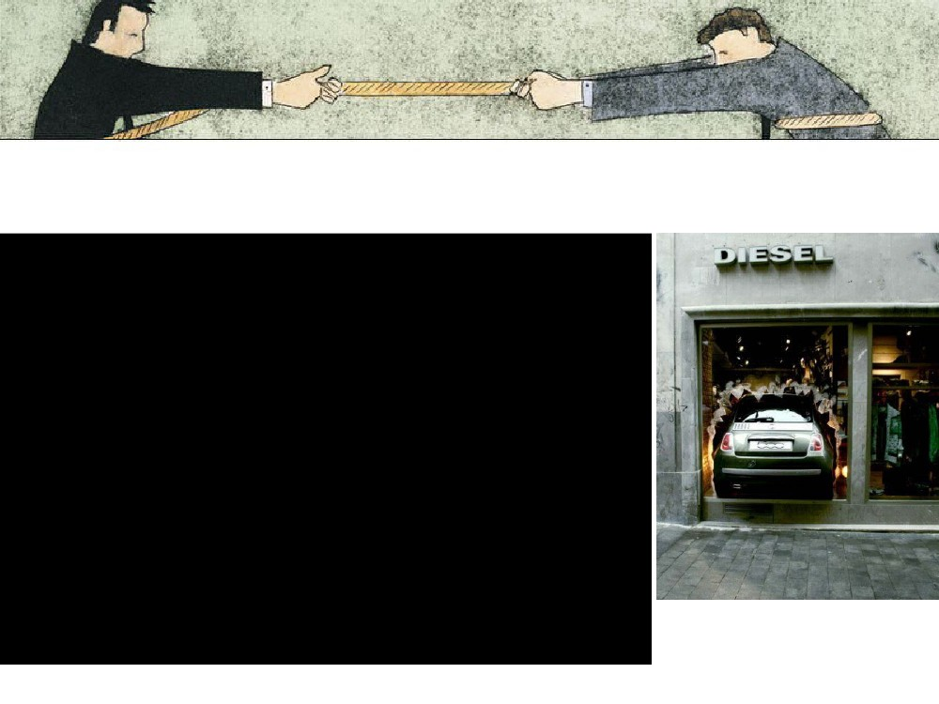
Hit and Run
•
•
A contestable market allows hit and run entry.
If a monopoly is making supernormal profits then
(assuming low entry and exit costs) new entrants
will be tempted to enter the market and take some
of this profit before leaving the market.
To stop this the monopolist will have to lower its
price to where ATC = AR ie it is only making
normal profits.
Thus the threat of competition will lead to a higher
output and lower price than under traditional
monopoly theory.
•
•


Hit and Run entry and cream-skimming
• Hit and run entry
– Short run entry into a contestable market seeking to
take some of the monopoly profits available and then
get out quickly
– Possible when the entry and exit costs are low
– Possible when the existing firms are charging high
prices relative to cost
• Cream-skimming
– This strategy involves finding segments of the market
that are high in value added (or high profit margins)
and exploiting those markets by selling only to the
most profitable parts of the business
– E.g. business post rather than household mail
e.g. EOS.

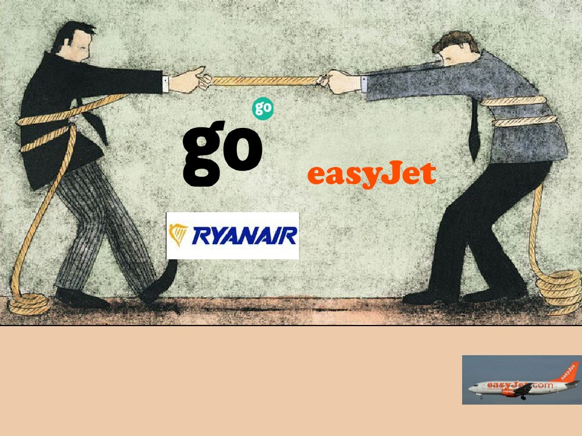
CASE STUDY: Low
cost airlines
Tutor2u – TIM notes

Phase 1
• Identify the key characteristics of a contestable market.
• Perfect knowledge
– no competitive disadvantages
– Access to best available technologies
• No barriers to entry / exit
– No sunk costs / irrecoverable set up costs
– Legal freedom
• Number of firms?
– Many or few!

• As is often the case with many industries that you come
across in economics, you may not know a great deal of
detail about them.
• A detailed knowledge of the industry is not necessary but
you can think about what the basic business activities of
firms within such industries are.
• Think about the following questions:
Phase 2
• Identify what you would consider to be the 5 main
airline firms based in the UK.
• Identify the main UK airports from which they fly.
• What are the main destinations to which they fly?
• (A general outline will be sufficient - you do not need
to go into great detail here!)
Info
•
The whole market might be classed as the 'market for airline travel', but
within that area there may be lots of what could be called 'micro-markets',
each of which is subject to competition.
For example, the London to Dublin route could be seen as being one market
whilst the Birmingham to Malaga route another.
In this case, therefore, there might be many markets making up the 'whole
market', each of which could contribute to the firm's overall profits and which
can be subject to entry and exit relatively easily.
What may make things even trickier is that larger airline carriers could also
be competing on these routes; British Airways, for example, may well see
opportunities to increase its scope for developing its business by using
some of its spare capacity to fill profitable routes it does not yet fly.

•
•
•
Phase 3
• Think about the types of costs a firm might incur in
running a four times daily service to and from Bristol
and Edinburgh.
• What might be the key factors determining the
demand for such a route?
• Identify the key market segments in flying routes
within the UK and to key destinations in Europe.
• Let's now return to the key characteristics of contestable
markets and ask whether the behaviour of firms in this
industry seems to match with the predictions of the theory.

Phase 4
1. Make brief notes on what you think might be the price
structures of the five main airlines you identified in
Phase 2?
2. Then take a look at the notes provided.

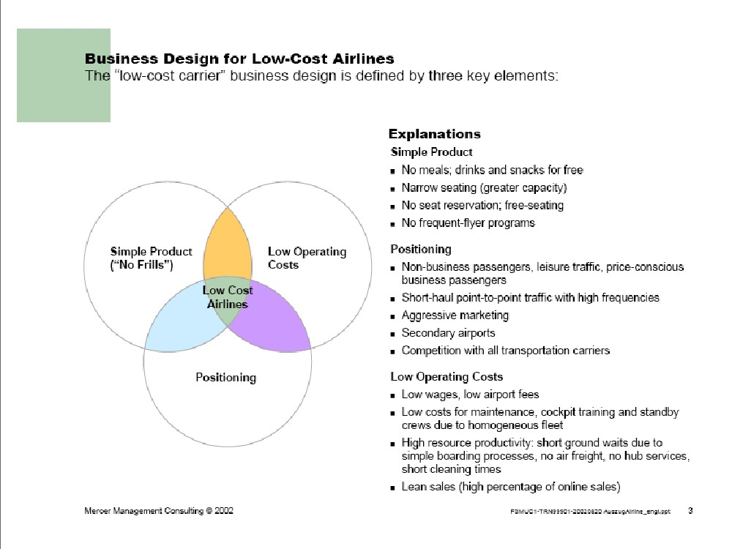
Tutor2u – TIM version
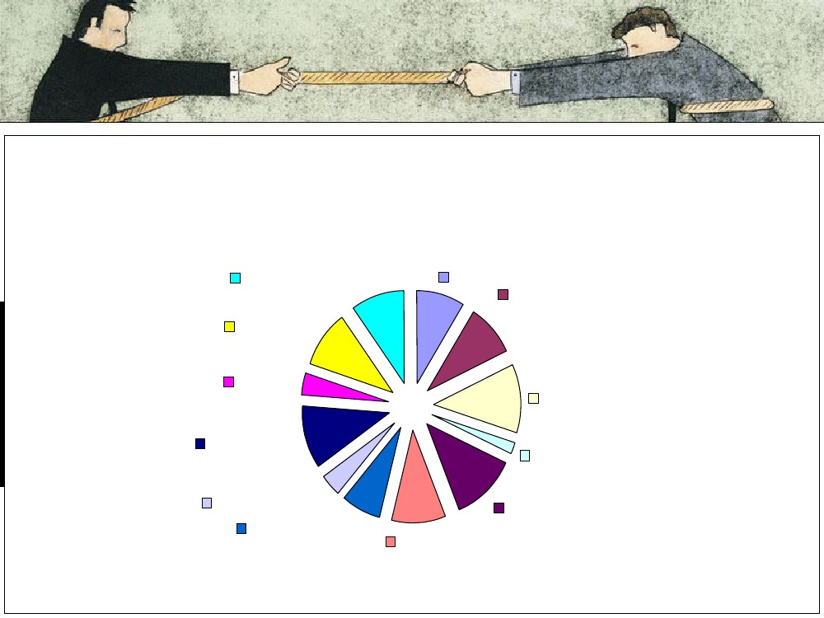
The cost of an Easy Jet flight
Maintenance, 10%
Crew, 10%
Tax, 4%
Profit, 9%
Groundhandling,
9%
Airport, 12%
Credit card, 2%
Administration ,
12%
Aircraft, 11%
Advertising, 4%
Navigation, 7%
Fuel, 10%

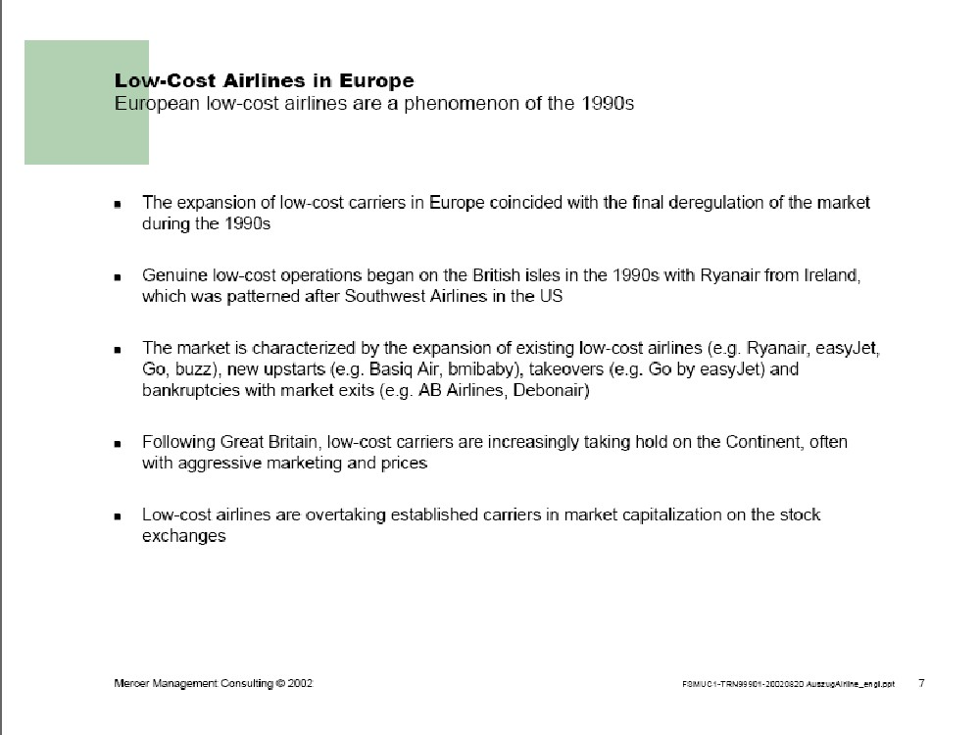
Tutor2u – TIM version
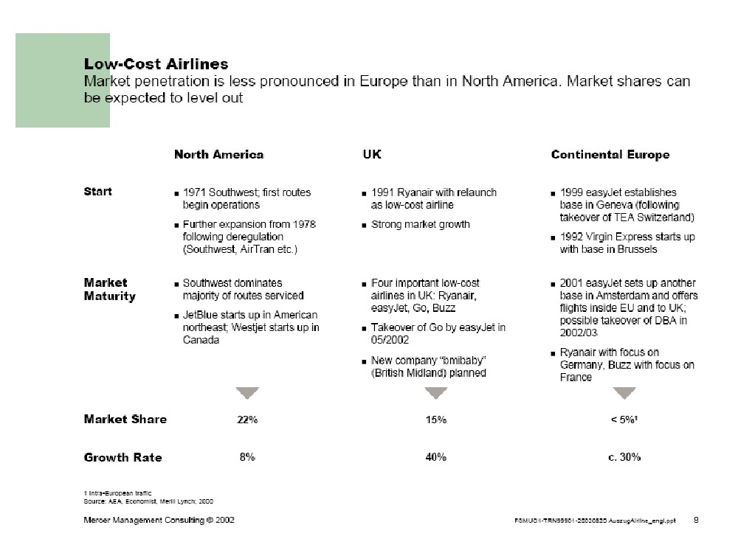
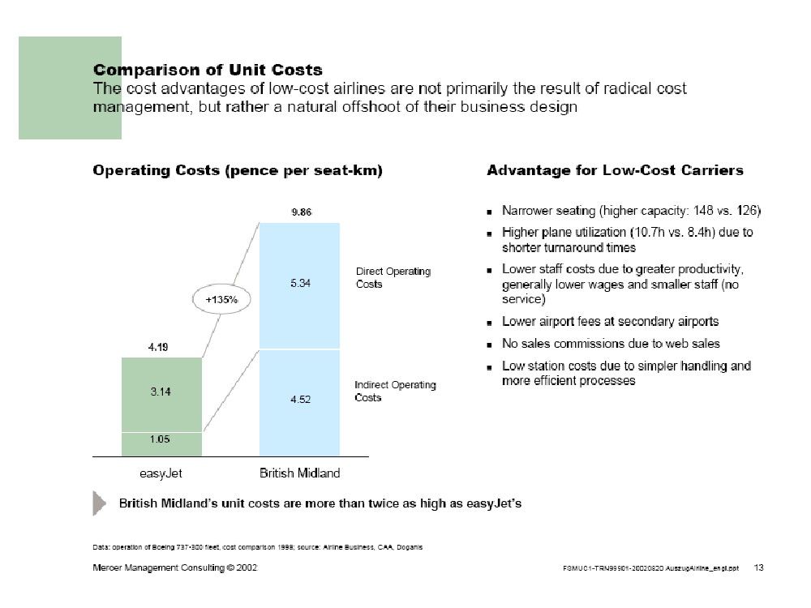
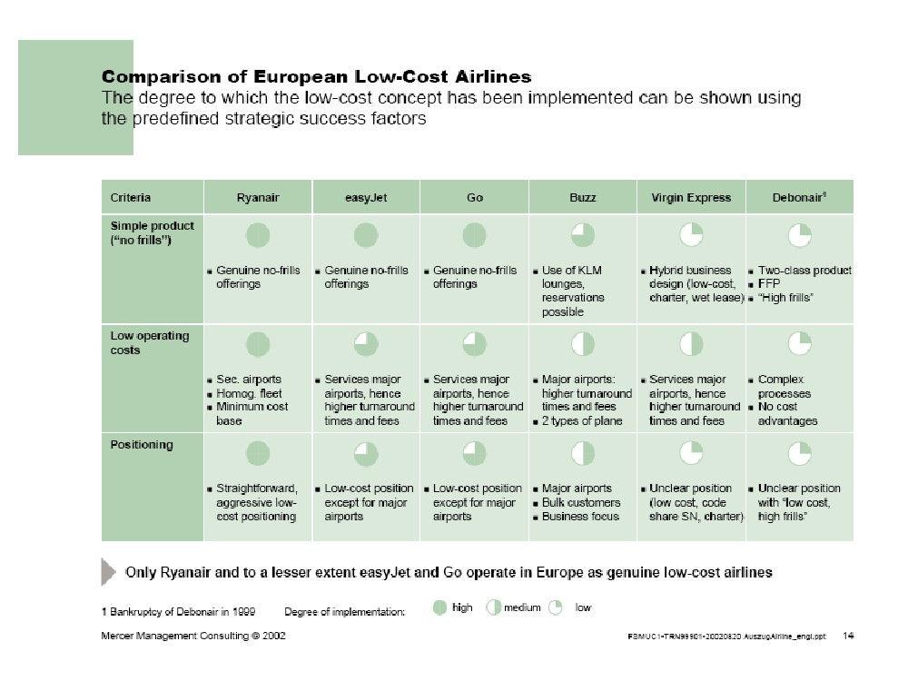
Tutor2u – TIM version
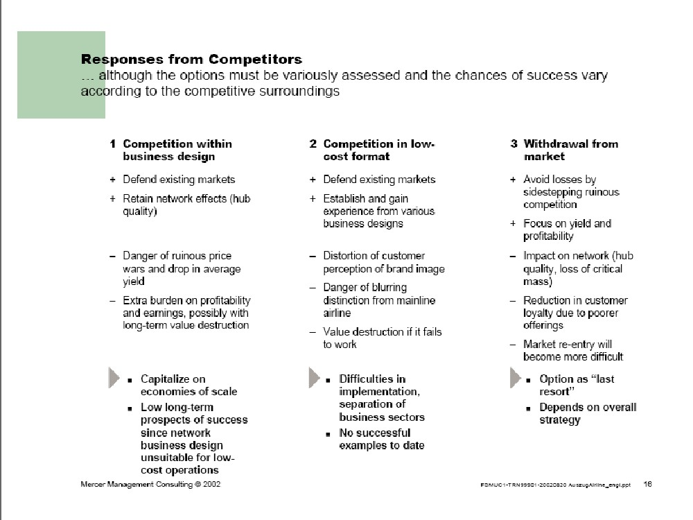

Competitive response
•
Today, major airline carriers are judged according to their "low-cost" label. As a result, the
biggest impact of Low Cost Carriers (LCCs) on business travel might soon lie in the
reactions of traditional airlines. To fight back against the cheap fares advertised by LCCs,
major carriers have adopted two parallel strategies:
First, they have focused on the quality of their service (their line is, in short: we do
not skimp on service).
Second, they have launched low fares of their own to meet the LCCs in the price
war.
This has been understood more quickly in the UK than anywhere else in Europe. For
companies, the issue of "low-cost carriers" is "out of date". The focus is now about
leveraging traditional airlines low fares. Large German and Dutch companies are also
heading in this direction. Potential cost cutting is likely to grow in the months ahead. Major
savings opportunities await companies, providing they are able to take full advantage of
them."
Source: Quote taken from What benefits do low-cost carriers really bring to business travel in Europe?, a 'White Paper' report from Carlson Wagonlit Travel [PDF, 260
KB]
•
•
•
•
•
To what extent is entry and exit in the market 'costless'?
As Baumol comments, no market entry or exit is completely costless but the key
principle is the how far an entrant would suffer damage as a result of entering and
subsequently leaving the market. This is where the work you did on 'micro-markets'
above will be relevant.
How would you describe the market structure of the low cost airlines industry?
Looking at the pricing strategies of each company in this market, is there evidence that
fierce competition is succeeding in driving prices down as we might expect in a perfectly
competitive market structure?
What response are the traditional airlines making to the impact of the low-cost carriers?
(The quote and link below may be of help in pointing you in the right direction).
•
•
•
•
Tutor2u – TIM version
Homework

Plenary: What is that “Next” tablet computer about?
• Extend brand?
• Short-term profits to be
had?
• Hit and run?


